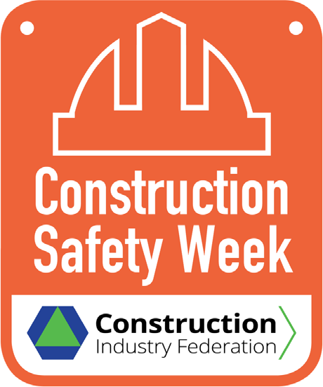TOOLBOX TALK

– Drive Safe

BACKGROUND
- Unfortunately, many people die on our roads every year. Up to 21st September this year, 106 fatalities occurred on Irish roads from 95 fatal collisions:

Category | 2021 (up to 21/09/’21)
Driver | 57
Passenger | 13
Pedestrian | 12
Pedal Cyclist | 4
Motorcyclist | 19
tbc. | 1
Totals | 106
- Reportedly, 1 in 10 drivers admit to regularly texting while driving. According to the Road Safety Authority (RSA), drivers are 4-times more likely to crash if using a handheld phone while driving, and texting increases the risk substantially.
- Of the 85 drivers and passengers killed in seatbelt-equipped motor vehicles in 2020, over a quarter (26%) were not wearing a seatbelt.

WHAT CAN YOU DO?
Be aware of the four ‘killer-driving behaviours’ reported by An Gardai Síochána, which are:
- speeding, (b) drink and/or drug-driving, (c) not fastening seat belts, and (d) using a mobile phone while driving. Plan your travel, monitor weather forecasts, and undertake regular checks of your vehicle(s) to include:
  - All lights clean and functioning
  - Tyre condition and thread depth (minimum limit of 1.6 mm, with 3 mm recommended for winter driving)
  - Windscreen wipers (no cracks, tears, or splits in the rubber)
  - Fill your washer bottle with windscreen wash
  - Service to schedule (inclusive of addition of anti-freeze to engine coolant)
  - Battery capacity (if greater than 3 years old, should be checked)
  - Carry a de-icer spray (to make your own, add 1-part white vinegar to 3-parts water).

FOR MORE INFORMATION: https://cif.ie/safety-week/

#CIFSafety21

