Contributor: Declan Grady (Group EHS Manager Jones Engineering)
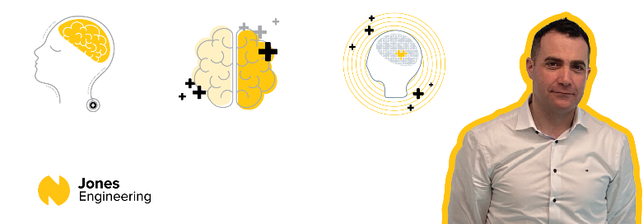
At Jones Engineering, we are committed to improving the lives of those who work with us, creating a healthy working environment where dignity and respect are key values. Every voice is important, and we take time to listen. We provide employees with the resources to make healthier living and lifestyle choices. We offer all of our employees a dedicated Employee Assistance Programme through Spectrum.life.
Mental Health & Wellbeing
On construction sites, workers are faced daily with visible signs around site e.g. ‘wear a hard hat’ but the signs that a co-worker is struggling with their mental health may not be as obvious. For many years, it was considered taboo to talk about mental health at work and other public places for fear of being judged or labelled. Fortunately, the stigma over talking about mental health is changing.

Mental health problems are common, even more in construction than in other industries and they can affect anyone at any time. It is important to treat mental health like we do physical health. We do not blame individuals for getting sick so we should be accepting of individuals who may be struggling with mental‐health issues.

We as individuals love to mentally compartmentalise, keeping our work and private lives separate. However, while this approach sounds logical, it’s not how our brains are wired. Issues at home deplete our personal resources, making it more difficult when work demands increase. In the same way, workplace issues will spill into our personal lives, and this could worsen our mental health. Our wellbeing is determined by a combination of:
- Biological factors e.g. physical health, genetics, diet, sleep, age
- Psychological factors, e.g. beliefs, mental health diagnoses, perception, addictions
- Social factors, e.g. relationships, family, culture, work, money, housing

Mental health covers a wide range of issues, including mild or moderate anxiety and stress, drug and alcohol abuse and disorders such as severe depression and schizophrenia. However, worker’s mental health and well-being also relates to their general mental and emotional health and their ability to cope with the normal stresses of life. Mental wellbeing, psychosocial risks and work-related stress are among the most challenging occupational safety and health concerns for construction workers. The cost of mental health issues in the workforce is significant in terms of days lost at work, health and safety implications, social isolation and even the risk of self-harm or suicide.

Mental Health affects everyone differently, which makes recognising a problem difficult. Some proactive ways to identify a mental health problem include:

Early Warning Signs | Identifying Changes | Identifying Challenges
Increased tiredness  Withdrawn  Greater procrastination  Chaotic work patterns  Short temper | It is not always easy to  understand or deal with changes. We all process change  differently, but our Mental Health is always affected. | Challenges affect our mental health as they alter the way we process information. These challenges could be one of or a combination of biological, psychological or social factors.
Tips to discuss Mental Health

Don’t be discouraged by the fear of saying something wrong. When people are struggling, they often feel isolated; but knowing someone cares – especially at work – helps us all feel less alone.
- The best way to start a conversation is to use your own words and be direct.
- Letting your coworker know you’re there to talk, whenever they are ready, can be meaningful and supportive to someone.
- Pay attention to your verbal and non-verbal behaviours and continue to listen before speaking throughout the conversation.

Minding our Mental Health

Our level of mental health can change as we go through life, and even on a daily basis. Good mental health helps us stay safe, happy, and productive on the job. Resilience helps us to bounce back when things get tough. Here are things we can do to look after our mental health.
- Keep stress levels in check.
- Making sure we get enough sleep and enough exercise.
- Making sure we maintain a healthy diet.
- Take time out to relax and do the things we enjoy.
- Be there for your co-workers.
- Know when it is time to ask for help.

One of the most important things we can do if there is something bothering us is to talk to someone. This can be a trusted friend or family member. Talking about how we feel and sharing our thoughts and worries can help us to feel better and can help us to come up with ways of coping with our feelings and emotions. If you are going through a hard time, you might want to think about it in your own head before talking to someone else. Maybe you do not know how you feel yet, or maybe you think it is too soon to discuss what is happening and that is OK. Talking about mental health issues is NOT a sign of weakness. It takes strength and courage.

Remember that good days for your wellbeing won't always look the same. We don't always have the same levels of energy or motivation. Be kind to yourself and do what feels right for you in the moment.

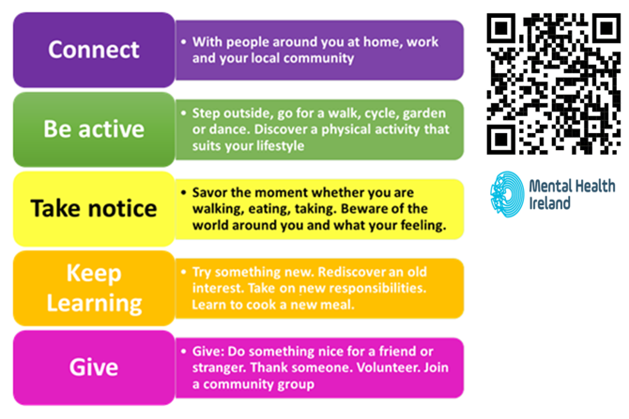

Support is always available:

Free & Confidential 24/7 Construction Industry Helpline & App
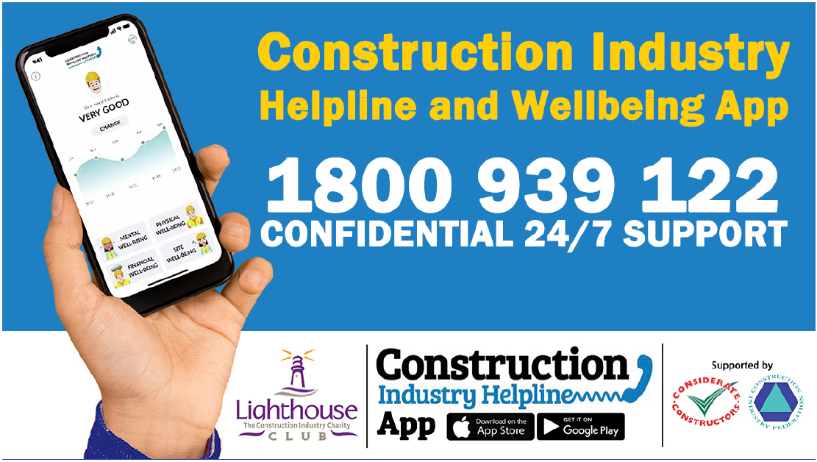
The Construction Industry Helpline app is a preventative tool packed full of information, advice, and guidance on mental, physical and financial wellbeing matters.
For more information, visit: https://www.constructionindustryhelpline.com/app.html

Build Health  (Available 24/7)  Webpage: https://wellbeing.spectrum.life/cif/ | Samaritans  (Available 24/7)  Ph. 116 123  Email: jo@samaritans.ie | Aware Support Line  (Available Monday to Sunday from 10am - 10pm.)  Ph. 1800 804 848  Email:  supportmail@aware.ie | Construction Workers’  Sick Pay Trust  Webpage: www.cwspt.ie  Email: sickpay@cwspt.ie  Ph. 01-497 7663
50808  (Available 24/7)  A free24/7 text service, providing everything from a calming chat to immediate support.  Free Text: HELLO to 508080 | Your Mental Health  (Available 24/7)  Text YMH to 50808 - a free and anonymous text support service  www.yourmentalhealth.ie | Pieta  (Available 24/7)  Ph. 1800 247 247  Text: HELP to 51444 | Healthy Ireland  Webpage:  www.gov.ie/en/campaigns/together
Mental Health Ireland
Ph. 01 284 1166
Email: info@mentalhealthireland.ie

We all struggle in life from time to time but with the right support, we can get through it.

