‘Safe Access and Egress’
Get There, and Back … Safely!
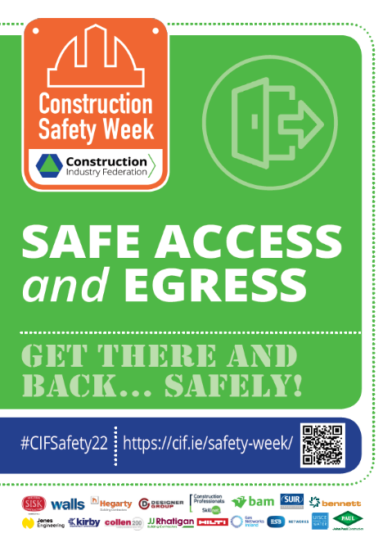
The term ‘Access and Egress’ covers a broad range of potential hazards, including travel to/from work, the interface of mobile plant and people (workers and members of the public), work at height, excavations, uneven ground etc.
How do we get there, do the job and get back home safely?
The above statement is a key consideration – all persons set-out to return home safe after work completion, but this is not always the case. There is a need for pre-planning and for adherence to safe working practices. All workers have a duty of care to look after themselves and their colleagues – if you spot something that is unsafe, fix it! Good housekeeping is a proactive means for addressing the risk of slips, trip and falls in the workplace.
Panel Contributions
Tim Dowling, Health and Safety Authority
- Safe access and egress cover so many different topics - it is a part of the planning of every particular task and a key part that needs to be examined.
Louise Ormsby, John Sisk & Son Ltd.
- Using BIM and 3D modelling at a pre-construction stage will allow for the planning of travel routes across all stages of construction. Consider exclusion zones around site hazards (e.g. excavations).
- Ladders must be suitable for all seasons.
Sean Mannion, Ward and Burke Construction Ltd.
- Embrace technology, embrace innovation. It is easier to communicate risk by showing a picture rather than reading a document. Visualize the work and how to protect persons. If you spot something that is unsafe, fix it!
- Place sufficient focus on safe travel, including the securing of loads.
Top Tips!
- Consider the travel distances involved, and plan accordingly.
- Plan for safe access/egress at the planning stage, not when issues arise!
- Work areas and welfare facilities should be large enough to be safe and healthy and be adequate with regards to stability, ventilation, fresh air, temperature and lighting.
- Pedestrians and vehicles must be able to circulate safely (i.e. segregated walkways).
- Plan for normal and abnormal work hours.
- Embrace techniques, technologies and innovations (e.g. BIM), which assist in better visualisation of site progress and potential hazards across the various stages.
- Floors, walls, ceilings, roofs, doors, gates, loading bays and ramps must be safe.
- Traffic routes, entrances and exits must be kept clear.
- Adoption of a ‘clean-as-you-go’ approach has proven effective in minimising the associated risk of slips, trip and falls in the workplace resulting from poor housekeeping.

