Safe Control of Hazardous Energies
Plan the Work, Work the Plan!
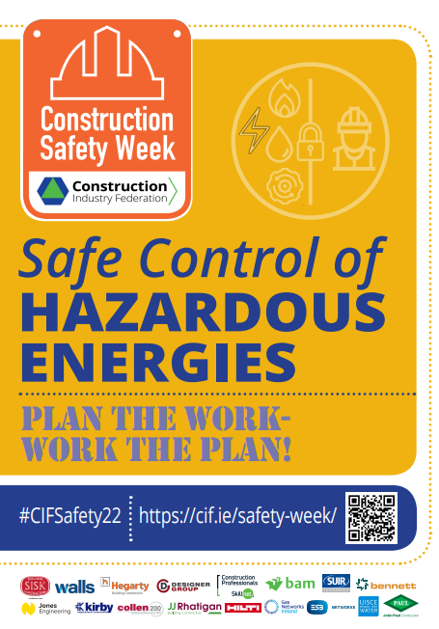
Contractors are responsible for managing the risks associated with work near overhead electricity wires, underground cables, gas and water pipelines, and other infrastructure.
Competent persons need to review past site records and utility drawings in advance of works and to liaise with the respective utility providers.
Unintended contact with utility services is a relatively frequent occurrence; last year, Gas Networks Ireland responded to over 400 incidents of damage to its underground gas network. Plan work and take due care in proximity to hazardous energies.

Panel Contributions
Tom Quinlan, Designer Group
- A hazardous energy could be defined as something that is uncontrolled, so when we don’t put a proper control in place, that energy could become hazardous through the release of energy. It’s okay to say you don’t know what to do - seek assistance.
Owen Wilson, Gas Networks Ireland
- We cannot eliminate the hazard; we need energy to heat and power our homes and much more. The value is having a concentration of energy to use in a valued way. Pressure alone is enough the tear the human body apart. A car tyre contains approximately 2 bar pressure, whereas the pressure range of gas pipelines is from a few millibar to circa 85bar (40-times that in a car tyre).
Jason Flannery, John Sisk & Son Ltd.
- Proper planning is essential. Empowerment of persons to stop is so important; do not be afraid to say it’s unsafe to proceed. When it comes to hazardous energies, constraints whether financial or project timelines do not apply, a safe focus must take priority.
Timmy Harnett, Irish Water
- If you had a leak or a break in a service, the effect it has on the surrounding area needs to be considered, such as saturated ground conditions. Before any equipment is energised, checks must be done and signed-off as safe. Ensure change control processes are utilised, re-assess as needed.
Niall Lohan, Ward and Burke Construction Ltd.
- Prior to pressure testing/energisation of utility services, there is a need to consider temporary works, ensure safety zones are in place, calibrations are checked, and the work is undertaken by competent personnel. For existing infrastructure, avail of resources such as Dial before you Dig, consider use of permits to open ground, check drawings, engage competent persons with CSCS Location of Underground Services, and use calibrated monitoring equipment. There are a lot of aids to assist. Commence planning early and engage with the service providers.
Michael Murray, ESB Networks
- Electricity is safe, if controlled. Construction companies are great at developing systems, process and procedures but there is a need for continued focus on developing a safety culture – treat people like family. Rules are there to ensure people get home safely and this needs to be understood by all. Wear suitably rated Arc Flash personal protective equipment where required.

