CIF Submission to
Prepared for the

Construction Industry Federation

March 2017

Committee on Budgetary Oversight

28th March 2017

Table of Contents
Executive summary and Recommendations i
1. Introduction 1
1.1 This Submission 1
1.2 Construction Industry Context 3
1.3 Prospects for the Construction Industry 4
1.4 Skills Capacity Issue 4
1.5 Building Cost Inflation 5
1.6 Recommendations 7
2. Key Bottlenecks and RationalE for Public Investment 8
2.1 Does Ireland have an Infrastructure Deficit? 8
2.2 Key Bottlenecks in the Economy 10
2.3 Addressing Long-Term Infrastructure Planning 12
2.4 Why Invest in Public Infrastructure? 13
2.5 Recommendations 15
3. Public Capital Investment Trends 17
3.1 Public Capital Investment Review 17
3.2 Public Capital Investment Prospects 18
3.3 Fiscal Space and the Implications for Construction Investment 24
3.4 Flexibility in the Fiscal Rules 26
3.5 Recommendations 28
4. Other Sources of Funding for Public Infrastructure 30
4.1 European Investment Bank (EIB) 30
4.2 Irish Strategic Investment Fund (ISIF) 31
4.3 Capital Receipts 32
4.4 Public Private Partnerships 33
4.5 Investment Priorities for the Medium-Term 33
4.6 Recommendations 33
5. Appendix 1: Capital Plan Allocations for 2016-2021 35
6. Appendix 2: Current Investment Priorities for Health Sector 1
7. Appendix 3: Pipeline of Transport Projects 2
8. Appendix 4: Fiscal Space Calculation 3

List of Figures
Figure 1.1: Value of Building and Construction Output (Current Prices, €bn) 3
Figure 1.2: Construction Tender Price Inflation 1998-2017F 6
Figure 1.3: Building and Construction Inflation 2006-2016 6
Figure 2.1: Projected Change in Population to 2046 14
Figure 3.1: Public Capital Programme Allocations by Sector 2008-2017E 18
Figure 3.2: General Government Fixed Investment (% of GDP, 2015) 20

List of Tables
Table 2.1: Projected Population by Age Cohort, Census Years 2016-2031 (000s) 10
Table 2.2: Population Growth by Age Cohort, Census Year 2016-2031 (%) 11
Table 2.3: 10 Counties with Highest Population Growth, 2011-2016 11
Table 2.4: Regional Population Projections, 2016-2031 (000s) 12
Table 3.1: Public Capital Expenditure 2008-2017 17
Table 3.2: Exchequer Gross Voted Capital Expenditure (2016-2021, €m) 19
Table 3.3: Sources of Total Expenditure in the Public Capital Programme (2017, €m) 20
Table 3.4: Department of Education & Skills: Voted Capital Expenditure (€m) 21
Table 3.5: Department of Health: Voted Capital Expenditure (€m) 22
Table 3.6: Housing, Planning, Community & Local Government: Exchequer Capital Expenditure and PCP Housing (€m) 23
Table 3.7: Department of Transport, Tourism & Sport: Voted Capital Expenditure (€m) 23
Table 3.8: Indicative Allocation of Available Net Fiscal Space 2017-2021 25
Table 4.1: EIB Projects: Number & Value in Ireland, 2012-2016 30
Table 4.2: ISIF Regional Economic Impact 2016 (%) 32
Table 4.3: ISIF & Third-Party Commitments (31 December 2016) 32

Executive summary and Recommendations
The CIF welcomes the opportunity to inform the Budgetary Oversight Committee on current issues in the construction industry. Although reports from the Ulster Bank Purchasing Managers Index (PMI) suggest activity in the Irish construction industry is growing at a robust pace each month, the reality is that the industry is recovering from an exceptionally low base and the recovery has been predominantly concentrated in the building sector and in the Dublin region. The immediate concerns for the industry are as follows:

- What is now an infrastructure crisis is threatening Ireland’s future economic growth, the quality of services for Irish citizens and our ability to deal with Brexit and other external shocks;

- A concomitant threat to the civil engineering sector, due to the much reduced Exchequer capital allocations for public infrastructure, including roads, water and wastewater services;

- The sharp reduction in public capital investment during the financial crisis, which has exacerbated Ireland’s infrastructure deficit, not just in terms of housing, transport and water services, but also in health and education, with adverse consequences for the economic recovery and competitiveness and our ability to attract foreign direct investment (FDI);

- The differences between construction activity levels in Dublin and the rest of the country, which is generating capacity constraints in the Dublin region, while also delaying the economic rebalancing process;

- The implications for residential and non-residential projects which are unable to proceed due to the lack of investment in roads, water and wastewater services over the past decade.

Investment in Ireland’s infrastructure has been neglected since the financial crisis
The economy is growing at a solid pace, and the quantity and quality of infrastructure delivered by the construction industry will play an important role in that economic recovery. However, investment in Ireland’s infrastructure has suffered since the onset of the financial crisis. The level of Exchequer capital investment fell to less than 2 per cent of GNP in 2015/2016, from 5.6 per cent in 2008, and is projected at just 2 per cent of GNP in 2017. This has led many stakeholders to call for an increased level of public capital investment in infrastructure to sustain the economic recovery which has been underway since 2014.

To begin with the Taoiseach, Enda Kenny, stated that “the importance of infrastructure investment is recognised in the Programme for Government. This is reflected in the inclusion of €5 billion of additional capital expenditure in the period to 2021 which is over and above the €27 billion Exchequer capital investment provided for in the Capital Plan published last year.”

The National Competitiveness Council has stated that: “Economic growth, demographic pressures and a sustained period of underinvestment in infrastructure mean there is a manifest and urgent need to increase investment in essential economic infrastructures”. It further acknowledges that the scope to improve the infrastructure stock “must be guided by adequate levels of investment and by identifying and prioritising those investments which contribute most to Ireland’s long term competitiveness”, while also addressing “enterprise needs and bottlenecks.”

The Vice President of the European Investment Bank, Mr. Andrew McDowell, stated in 2016 that “Few places justify enhanced support for infrastructure investment as much as Ireland. The strength of the Irish recovery has highlighted significant planning and infrastructure bottlenecks, including but not limited to transport, housing, water and broadband, which threaten to hold back both the continued pace of the recovery and its regional impact.” Mr. McDowell has also stated that “Notwithstanding the evident infrastructure gaps and other pent-up investment requirements, total EIB exposure to Ireland remains, as a percentage of GDP, below the EU average”.

Ireland at bottom of the European league when it comes to public capital investment
Notwithstanding the uncertainties with regard to Ireland’s GDP as a measure of economic output, Ireland spends the lowest amount on exchequer capital investment as a percentage of GDP. Figure 3.2 (p22) shows that Ireland was bottom of the European league in 2015 in terms of the rate of general government fixed investment as a percentage of GDP. The Eastern European countries were predominantly at the top of the chart. Unless the existing bottlenecks, as discussed in this report, are addressed, costs in the economy will increase and the potential for investment and jobs by the indigenous enterprise sector and multinationals will be dampened. The option to just ‘do minimum’ when it comes to investing in public infrastructure is not a sustainable option.

Investment in infrastructure is essential to sustaining the economic recovery and competitiveness. The quality of infrastructure is a key prerequisite for an economy to function efficiently and effectively.

The Capital Plan allocated €27 billion of Exchequer funding to gross voted capital expenditure over the period 2016-2021 (€4.5 billion on average per year). Budget 2017 allocated an extra €6.66 billion between 2017 and 2021 over and above the corresponding figures in the Capital Plan. However there is some inconsistency between the Summer Economic Statement, which indicates that an additional €5.14 billion is to be allocated to capital expenditure in the period 2017-2021. Of this figure, €2.2 billion has already been allocated to housing, leaving €2.65 billion to be allocated to new projects in the mid-term review of the Capital Plan.

This submission calls on Government to recognise that investment in the State’s infrastructure has been neglected over the past decade, and that substantial investment is needed urgently to sustain the economic recovery and cater for our expanding population. The onus is on Government to examine all possible avenues to address Ireland’s infrastructure deficit, and prioritise investment where there are immediate bottlenecks (which are elaborated on in this submission), in the review of the Capital Plan, given the long lead in time to construction projects. The CIF acknowledges the constraints which are imposed by the fiscal rules but recommends that the current rules be used to Ireland’s advantage. The recommendations below set out potential areas which should be explored as a means of increasing the funding available for public infrastructure over the medium-term.

Indeed Professor Alan Barrett of the ESRI told the Committee on Budgetary Oversight in September 2016 that “Fiscal rules should not be so ridiculous that if there are expenditures that would genuinely add to the productive capacity of the economy, they should not be reflected in the scope we have to invest in capital.” He also said: “From an economics perspective, the notion of borrowing for productive purposes is in no way controversial. It is exactly what one should be doing, especially when interest rates are where they are now”.

The resultant crisis in the civil engineering sector
Civil engineering projects are predominantly funded by the public sector. The absence of new public infrastructure projects on any significant scale in recent years has led to a crisis in the sector. While some of the larger players can internationalise, many Irish civil engineering firms are reliant on a pipeline of medium-sized public sector infrastructure projects. However, investment levels in water infrastructure have been poor, reflecting Irish Water’s continued dependence on government funding. Moreover, with the bulk of the investment in roads (c.73%) in the Capital Plan 2016-2021, projected to represent ‘steady state’ investment in maintenance and renewal of the road network, there is likely to be limited scope for investment in new road projects. It is noteworthy that civil engineering has consistently remained an area of weakness in the Ulster Bank PMI, lagging behind the other sectors. Yet there is little or no inflation in civil engineering, indicating that now is a good time for the State to invest in civil engineering projects.

Ulster Bank Construction Purchasing Managers Index
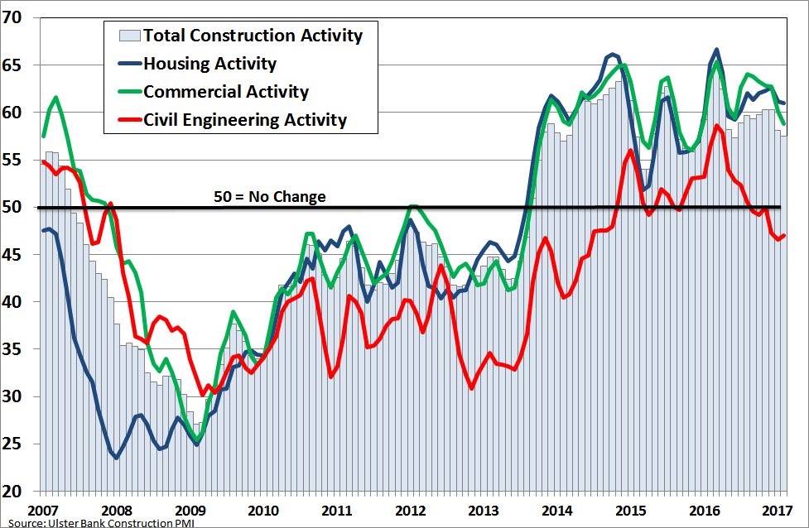
Regional pattern of investment
Much of the activity underway in the construction sector is concentrated in the Dublin Region, which is unsustainable in the medium-term. The forthcoming National Planning Framework (NPF) will influence the spatial pattern of development throughout the country. Based on current objectives, it is expected to deliver a more balanced regional development. The four cities outside Dublin are considered to have significant potential to complement Dublin, to absorb some of the strain that the Capital has been subject to in terms of accommodating growth in employment, housing need and infrastructural requirements. They will also be expected to be the focal point to drive growth and development in their regions. Beyond the city catchments, there is a network of towns that will be expected to play a similar role.

The NPF will have implications for investment in public infrastructure but will require significant up front spending on projects which can support sustainable and balanced regional development. But there is a notable absence of, for example, the M20 Limerick to Cork motorway in the Capital Plan, which is a key route in the context of the Atlantic Economic corridor and would be important to provide greater connectivity between the two urban centres and more generally between economic clusters in the south-west region. This road project would take at least 5 years to get through planning and go to procurement and until it is complete, it is likely to disadvantage the entire south-west region.

Investment in productive and social infrastructure in the regions will be important for the success of the NPF and will require a strategic approach to infrastructure provision at a national scale. This is to commence with the mid-term review of the Capital Plan.

Consequences of the sharp cutback in public infrastructure over a decade
The economy requires high quality infrastructure to function efficiently. Businesses and suppliers require efficient access, in terms of our road network; our population centres need a fully-functioning water supply and wastewater system; an expanding economy keen to attract high value jobs requires a best in class educational infrastructure, from primary through to post-primary and third level; and our expanding population requires a first class health infrastructure. However, almost a decade of cuts in productive (roads, water and wastewater) and social (housing, education and health) infrastructure has meant that:
- Significant residential and non-residential construction projects are unable to commence;

Irish universities are falling in the international rankings;

Our health services are often operating out of outdated facilities; and

The acute housing shortage has put at risk the potential to attract FDI and relocations as a result of Brexit.

We understand that the €200 million for investment in enabling infrastructure to deliver additional supply of social and private housing in the Local Infrastructure Housing Activation Fund (LIHAF), was four times oversubscribed. This is having repercussions for local authorities who have to provide the matching funds with those from the Exchequer to fund the LIHAF over the period 2017-2019.

The lack of investment in roads, water and waste water services over the past decade means that there is a risk that residential and non-residential building development will also be constrained in the medium-term.

Infrastructure investment has a positive effect on economic growth and jobs
The construction sector contributes to the productive potential of the economy, by providing and maintaining the physical infrastructure and buildings, which are critical for competitiveness. Moreover, other firms back through the supply chain also contribute to the economy through the various output and employment multipliers, as the additional wages and profits generated in these firms are spent on goods and services in the wider economy. Independent estimates suggest that 10 direct and indirect FTE (full-time equivalent) work years are generated per €1 million of construction investment. In terms of Gross Value Added (GVA), the direct and indirect multiplier associated with a €1 million investment in construction raises economic activity by €0.7 million. When induced impacts are included, the employment multiplier increases to 12 and the GVA multiplier increase to almost €1 million.

In the four years since employment in construction reached its lowest level (Q1 2013), the industry has generated the highest proportion of the total jobs created across the economy, at almost 23 per cent. But employment in the industry is currently only at 50 per cent of where it was in 2007.

Challenges facing the sector
There are a number of challenges currently facing the industry with regard to skills and the threat of building inflation. An unfortunate development has been the upward trend in building tender price inflation, which is currently running at 6.3 per cent per annum. This is indicative of the lost capacity in the industry during the financial crisis as well as the rising cost of labour, sub-contractors and materials. On the skills front, the total sector labour requirement is projected at around 112,000 (expansion and replacement) over the four years 2016-2020. This challenge needs to be considered in the context of a skills gap of over 400,000 each year by 2021 in the UK construction industry.

RECOMMENDATIONS

Investment in Public Infrastructure
- The Irish Fiscal Advisory Council has expressed concern that Ireland’s quantum of capital expenditure is barely covering the depreciation costs of the capital stock. If additional finance does not become available, this increases costs in the economy in the short term (as poorer infrastructure reduces efficiency) and in the medium- and long-term (due to the need to upgrade). At a minimum, the quantum of expenditure allocated to capital projects should be sufficient to cover depreciation and tackle the backlog in a number of sectors, notably housing, transport, health and education.

- There is a clear need to invest heavily in transport infrastructure over the coming years, so as to support both population growth and competiveness. In particular, as Dublin is one of the most congested cities in Europe, measures that address this problem will lead to productivity gains for the economy. In turn, this will increase competitiveness.

- The prospect of some form of customs checks on the border between Northern Ireland and Ireland, and with that delays to travel times, will reduce the productivity of cross-border road users. Improvements to the road network around the border region would mitigate these losses to productivity whilst also increasing road quality in a broader sense.

- The ageing of the population over the coming years will increase demand for services for older people. Whilst the private sector is likely to build nursing homes and retirement communities to cater for private demand, the State should ensure that public demand is catered for too. Capital investment that addresses these coming bottlenecks will free up housing stock and prevent old-age inequalities.

- Population growth in the period 2011-2016 was greatest in Dublin, its surrounding counties, and Cork and Galway, suggesting that urbanisation increased during the recession. With publication of the National Planning Framework, it is expected that this trend will continue over the coming years, with Dublin and the Mid-East likely to grow at faster rates than other regions. Although investment should be needs-based and should focus on the regions where demand is highest, this should not be at the expense of other regions.

Planning Best Practice
- The mid-term review of the Capital Plan should adopt best practice in terms of the planning and institutional framework for the roll out of capital infrastructure projects.

- The strategic infrastructure planning approval process in An Bord Pleanála works well. Every effort should be made to progress the planning phases of critical infrastructure projects through An Bord Pleanála at the earliest opportunity so that the statutory planning requirements can be addressed in the short term.

National Public Investment Target
- Ireland has been spending relatively little on capital expenditure when compared with other EU countries. The industry in other EU countries has called for the introduction, via legislation, of national public investment targets (e.g. as a percentage of output). Such targets could, for example, ensure that capital expenditure grows in line with the economy. The Government could consider this policy approach as a means of ensuring that the economy and public investment move in unison.

Cross Departmental Committee for Monitoring Public Sector Projects
- With the decline in the Exchequer proportion of the PCP over the past decade, the exact identity and nature of capital projects is difficult to discern. A centralised database of all capital projects being undertaken by the Exchequer and by semi-state bodies would provide stakeholders such as the CIF with greater certainty and clarity about ongoing and future work. In this regard a Cross Departmental Committee should be established to monitor progress on public sector construction projects on a quarterly basis and address any barriers which are impeding the delivery of projects on time.

- Whilst the Capital Plan provides for an allocation of funding to higher education PPP projects, there is general concern that the funding being allocated to the sector will not be sufficient to meet demand. Although an expansion of university places will be required to keep pace with population changes from 2021 to at least 2026, the Capital Plan does not appear to have accounted for this increase. The Government should re-evaluate this issue in the mid-term review of the Capital Plan.

- The absence of the proposed Cork-Limerick motorway (M20) and an outer Dublin Ring Road ((Leinster Orbital Route) from the Capital Plan has been put down to cost reasons. Given the strategic importance of the former and the significant pressure on the latter, we would welcome a review of why these projects are excluded from the Capital Plan.

Examine scope to use the Rainy Day Fund for infrastructure Investment
- The Government plans to allocate €1bn from the Fiscal Space to a Rainy Day Fund on an annual basis from 2019. Whilst this measure could act as a buffer against future shocks to the economy and the public finances, the Government could consider postponing the allocation for 2019, at least. This would allow for greater levels of public capital investment in 2019 than that which is currently planned. Where there are good projects that earn a return and add to the productive potential of the economy, there should be scope to use the rainy day fund.

Calculation of the Fiscal Space
- The CIF understands that a number of commentators have criticised the EU Commission’s methodology with respect to calculating the fiscal space available to the Government. In the methodology places too great an emphasis on recent unemployment rates, which in Ireland’s case were particularly high. The Government could request that the Commission reassesses the merits of this approach for countries that experienced significant unemployment in the recent past.

- In 2015, the Commission clarified the flexibility that is available to Member States around the fiscal rules: namely, these are the Structural Reform Clause and the Investment Clause. At present, Ireland would be eligible to invoke the former but not the latter, and significant structural reforms could be undertaken in Ireland. The Government should seek to invoke this clause as part of its submission of its budgetary plans for 2018 to the Commission and we encourage consideration of same.

Leverage EIB Office
- Ireland has been a recipient of European Investment Bank (EIB) funding for a number of decades and in 2016 13 projects received total funding of €825m. This stream of funding is of huge value to the economy and Government efforts to secure EIB co-financing of major projects should continue. However, the flow of funds is uncertain and competition has increased in recent years (since Romania, Bulgaria and Croatia joined the EU). The CIF encourages the Government to leverage the presence of the new EIB office in Dublin in its efforts to find ways to fund major infrastructure projects.

Review PPP Pre-procurement Process
- PPP arrangements provide for long-term strategic planning of infrastructure projects. They provide an opportunity to fund major long-term infrastructure projects competitively off balance sheet while also facilitating social and economic development. In the context of the fiscal constraints which exist, it is understood that a group has recently been established within DEPR to review the future of PPPs. This group should investigate the timely pre-procurement process involved on PPP projects to improve their efficiency.

Explore scope for EFSI funding
- Every effort should be made to explore the scope to secure as much additional funding as possible for infrastructure investment from the European Fund for Strategic Investment (EFSI). Key areas which the EFSI fund include transport, environment, health, energy and social housing. In regard to the latter the ESFI has set up a High Level Task Force to develop financing models for social infrastructure, an area in which the EFSI is keen to finance projects in the future and is already doing so in other countries.

Skills Capacity
- Apprenticeship training that is structured on a regional basis, in light of the demands of the relevant area, would produce tradespeople who could remain in their communities and regions and reduce the incentive to relocate to major cities. The result should be better qualified tradespeople living across a broader geographic spread, which should secure the sustainability of the construction skills base in the long-term. This will be important in the context of the forthcoming National Planning Framework which is expected to have more balanced regional development as one of its key objectives.

- The recommendations of the CIF’s Construction Skills report regarding the enhancement of the skill’s capacity of the industry should be implemented and Government should ensure that adequate funding is in place for Solas and the Education and Training Board network to deliver the requisite numbers of highly skilled apprentices to serve the industry over the long-term. Thereafter a strong pipeline of projects will be required to ensure that those trained remain in the Irish construction sector and are not drawn towards the UK where a significant skills gap is projected in the medium-term.

Construction Costs
- A Housebuilding Cost Working Group has been established, comprising stakeholders from Government and industry, to determine how (building and non-building) costs can be reduced so that more affordable supply can be brought to the market. In line with a 2015 recommendation of the National Competitiveness Council, which was never acted upon, it is recommended that the Housebuilding Cost Working Group also undertake a rigorous benchmarking exercise to determine whether Irish residential construction (building and non-building) costs are out of line with those of our key competitors.

- Introduction
  - This Submission
The CIF welcomes this opportunity to make a submission to the Committee on Budgetary Oversight. The construction industry is a vital sector of the Irish economy. The industry is responsible for providing the housing, social and productive infrastructure required to sustain economic growth and competitiveness and attract foreign direct investment. It is one of the most labour-intensive forms of economic activity and thus is also an important contributor to job creation and long-term productivity. In the four years since employment in construction reached its lowest level (Q1 2013), the industry has generated the highest proportion of the total jobs created across the economy, at almost 23 per cent.

The premise for this submission is the general consensus on the merits of investing in quality infrastructure which can add to the productive potential of the economy. The economy is growing at a solid pace, and the quantity and quality of infrastructure delivered by the construction industry will play an important role in that economic recovery. The public sector has a key role to play in the funding of such infrastructure which is important for sustainable and balanced economic development. However, Ireland experienced a sharply reduced level of public sector investment in infrastructure during the financial crisis, with the result that there are many stakeholders who have been calling for an increased level of public capital investment in infrastructure to sustain the economic recovery which has been underway since 2014.

The Taoiseach, Enda Kenny, has acknowledged that: “An island of 10 million people by 2050 presents a challenge for all of us. But if we are to turn this challenge into real opportunities we need to work together, in planning and investing in the infrastructure necessary for the medium to longer term.”

He further recognised that: “the importance of infrastructure investment is recognised in the Programme for Government. This is reflected in the inclusion of €5 billion of additional capital expenditure in the period to 2021 which is over and above the €27 billion Exchequer capital investment provided for in the Capital Plan published last year.”

The National Competitiveness Council stated that: “Economic growth, demographic pressures and a sustained period of underinvestment in infrastructure mean there is a manifest and urgent need to increase investment in essential economic infrastructures”. It further acknowledges that the scope to improve the infrastructure stock “must be guided by adequate levels of investment and by identifying and prioritising those investments which contribute most to Ireland’s long term competitiveness”, while also addressing “enterprise needs and bottlenecks.”

The Vice President of the European Investment Bank, Mr. Andrew McDowell, stated in 2016 that: “Few places justify enhanced support for infrastructure investment as much as Ireland. The strength of the Irish recovery has highlighted significant planning and infrastructure bottlenecks, including but not limited to transport, housing, water and broadband, which threaten to hold back both the continued pace of the recovery and its regional impact.”

Similarly, Professor Alan Barrett of the ESRI told the Committee on Budgetary Oversight in September 2016 that: “Fiscal rules should not be so ridiculous that if there are expenditures that would genuinely add to the productive capacity of the economy, they should not be reflected in the scope we have to invest in capital.” He also said: “From an economics perspective, the notion of borrowing for productive purposes is in no way controversial. It is exactly what one should be doing, especially when interest rates are where they are now”.

With Irish GDP forecast to grow at over twice the corresponding growth in the Euro area in the next two years, there are number of challenges with regard to addressing the infrastructure deficit. The key challenge is the constraint imposed by the fiscal rules under the Stability and Growth Pact which restricts the Government’s ability to increase expenditure, including capital expenditure. A second challenge is that the existing provisions set out for public capital investment will focus largely on maintenance and upgrading the existing stock.

This issue was highlighted by the Irish Fiscal Advisory Council which concluded that public investment over the forecast horizon of the Capital Plan 2016-2021 “is barely adequate to cover the estimated cost of depreciation of public capital, based on historic depreciation rates” which implies limited scope to increase the public capital stock over the medium term. All options need to be explored to find alternative mechanisms to fund infrastructure investment which are compatible with the fiscal rules. The third challenge is ensuring that investment is prioritised which adds to the productive potential of the economy and maximises the impact on competitiveness. These issues and others are addressed in this submission, which is structured as follows:

The remainder of Section 1 sets the context for the construction industry, where it is at currently and its prospects for the medium-term. It also examines a number of key challenges with respect to capacity issues and building cost inflation.

Section 2 examines the key bottlenecks in the economy and the rationale for investment in public infrastructure. The challenge regarding the long-term planning of infrastructure provision is also examined.

Section 3 reviews trends in public capital investment and examines future prospects. The implications of the fiscal space for construction investment are also examined together with proposal for alternative sources of funding.

The Executive Summary contains the main conclusions and recommendations.

  - Construction Industry Context
Official statistics from the CSO indicate that the construction industry has been in recovery for almost four years. Following a contraction in output volumes by over 60 per cent between 2007 and 2012, the industry began to recover strongly in 2013, albeit from an exceptionally low base. The volume of construction output increased by almost 50 per cent or 10.5 per cent on average per annum between 2012 and 2016. Preliminary estimates for 2016 show the value of construction output reached €15.5 billion in 2016 (5.5% of GDP). This corresponds to less than half of the corresponding value recorded in 2006 when the total value of output in the industry reached almost €34 billion or 18 per cent of GDP. Thus the industry is currently operating well below what is deemed to be a sustainable level of activity, of around 10 per cent of GDP. The activity is also predominantly concentrated in the building sector and in the Dublin Region.

The breakdown provided by the CSO shows that around one-third of the total value of building and construction put in place in 2015 was residential (67% in 2006), just over 6 per cent was roads (unchanged from 2006) and 60 per cent was other building and construction (26% in 2006).
      - Value of Building and Construction Output (Current Prices, €bn)
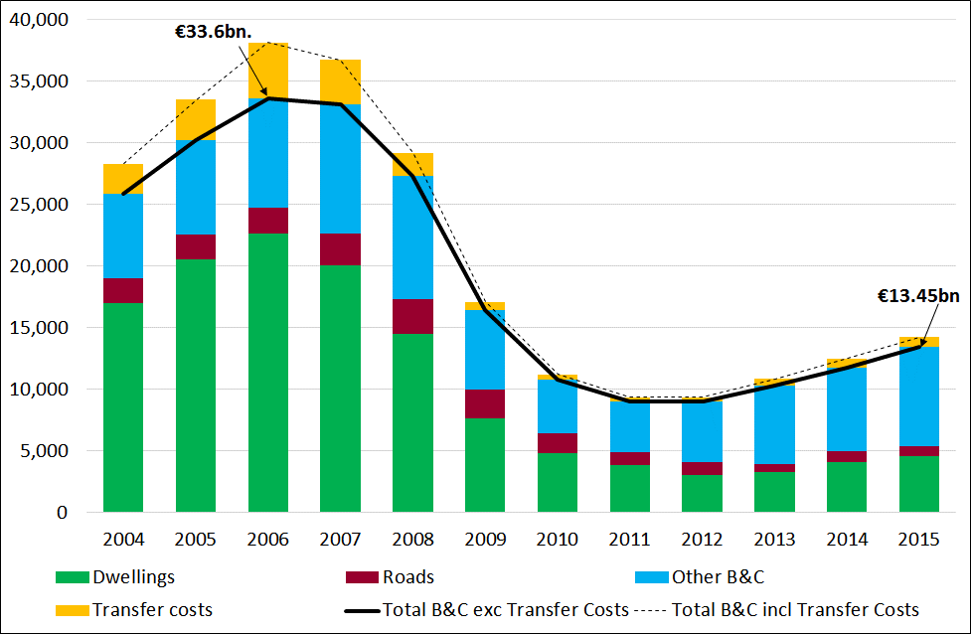
Source: CSO National Accounts

Having lost 180,000 direct jobs between Q2 2007 and Q1 2013, the industry has regained 41,800 jobs in the period since, which represents almost 23 per cent of the total jobs added over the period. A key issue of concern is the loss of capacity in the industry during the financial crisis, when the number of firms in the industry declined by 14,400 firms in the six years to 2014. The latest CSO data is that there were 47,349 firms in the industry in 2014 (the latest data available) with around 98 per cent of all enterprises employing less than 10 employees.

But activity in the Irish construction industry is growing at a robust pace with very encouraging developments reported each month from, for example, the Ulster Bank Purchasing Managers Index (PMI) Survey. It is noteworthy that residential construction activity continues to rise at a rapid pace, while commercial activity also remains very much in expansion mode, though the pace of growth had eased in previous months. However, civil engineering, has continued to lag behind the other sectors, with respondents reporting a fourth consecutive monthly decline in activity in February 2017.

Civil engineering sector in crisis
Focusing in particular on civil engineering, this submission wishes to acknowledge the situation which currently exists in the civil engineering sector. Civil engineering projects are predominantly funded by the public sector and the sector is already in crisis given the dearth of new public infrastructure projects in recent years. While some of the larger players can internationalise, many Irish civil engineering firms are reliant on a pipeline of medium-sized public sector infrastructure projects. It is noteworthy that civil engineering has consistently remained an area of weakness in the Ulster Bank PMI. Moreover there is little or no inflation in civil engineering, indicating that now is a good time to invest in civil engineering projects.
  - Prospects for the Construction Industry
The prospects for construction over the medium-term were examined in a separate report undertaken for the CIF in 2016. The output projections presented for construction in the period to 2020 were based on stated Government policy for residential and infrastructure provision in the Rebuilding Ireland Housing Action Plan and the Capital Plan 2016-2021. The scenario projected for construction output expects the overall volume of construction output to increase by 12.5 per cent in 2016, 8.5 per cent in 2017 and 7.1 per cent in 2018. The average annual growth rate in the period 2016-2020 is projected at around 9 per cent. The volume of construction output by 2020 is forecast to reach €20.2 billion (in 2015 prices), or almost 8 per cent of GDP. The scenario is based on an estimated 14,000 new dwellings in 2016, increasing to 20,000 units in 2018 and 32,500 in 2020.

These strong growth rates reflect an industry that was in recession for six years until 2013 and now needs to catch up with an economy and population that has expanded strongly in the meantime. Notwithstanding the uncertainty over Brexit, there is a substantial volume of work planned by the commercial and industrial sectors. There is also considerable pent-up demand for housing which, if delivered, could see the level of housebuilding by 2020 returning to more normal levels. Thus provided the required conditions are in place to facilitate this projected growth, including the necessary investment in infrastructure services (e.g. roads, water and waste water, the industry is on course to experience the most positive outlook for construction in a decade.
  - Skills Capacity Issue
Given the current positive momentum regarding the sector’s prospects, there is real concern that the industry is lacking the necessary skilled workers in the labour market and amongst those coming out of full-time education and training to meet the demands on it over the medium-term. Significant numbers left the sector at the start of the recession, and either upskilled or emigrated, while the unemployment rate, although decreasing, is currently at its highest for persons previously employed in construction. Moreover, as the overall construction workforce ages, there will be a greater need for new entrants who will need time to acquire the requisite skills and experience.

Based on an analysis of the implications of the construction projections set out above for skills demand, the total direct employment in construction is forecast to increase by 76,000 between 2016 and 2020. This would generate direct employment of around 213,000 by 2020. In addition there will be significant replacement demand for workers required to do the jobs of individuals who leave the labour market as a result of illness, retirement or death. The cumulative replacement demand in the period 2016-2020 is estimated at almost 36,000 construction workers. Thus based on an expansion (+76,000 jobs) and replacement (+36,000 jobs) demand, the total labour requirement is projected at around 112,000 over the four years 2016-2020. As well as those directly employed, there will also be others indirectly employed in the supply chain. This challenge needs to be considered in the context of a skills gap of over 400,000 each year by 2021 in the UK construction industry, which will be required to deliver the housing and infrastructure needs of the economy.

Encouraging more school leavers into apprenticeships would generate a pool of young talent to serve the industry for decades to come. The forecast total requirement for new apprentices in 2020 is around 4,000, over twice the intake in 2015. Thus an enhancement of the capacity is essential to ensure the right talent exists to equip the industry with the requisite skills that will best serve it in the long-term. Indeed the UK research goes further and calls for a greater emphasis on regional, needs-based training and upskilling to truly tackle the issues at play in a short timeframe. This issue also needs to be tacked in the Irish market, in anticipation of the National Planning Framework which aims to deliver more balanced regional development.
  - Building Cost Inflation
The issue of building and construction inflation was a major factor which contributed to the price of residential and non-residential buildings and infrastructure during the construction boom of the late 1990s through to 2007. Over the period 1998-2001, the annual average rate of construction tender price inflation reached almost 11 per cent. In the period 2004-2007, the annual rate moderated to around 5 per cent. With the onset of the financial crisis and the building crash, tender prices plummeted by one-third between 2007 and 2011. Since prices bottomed out in 2011, tender prices have risen sharply in the past five years by over 27 per cent or around 5 per cent on average per year. The most recent data available shows tender price rose by 6.3 per cent in 2016 and the SCSI expects tender prices to rise by 3 per cent in the first half of 2017. Tender prices are likely to continue rising in the medium-term due to higher costs of labour, subcontractors and materials. However, this inflation measure only relates to residential and non-residential building work as opposed to civil engineering, which has recoded little or inflation, indicating that now is a good time to invest in civil engineering projects.
      - Construction Tender Price Inflation 1998-2017F
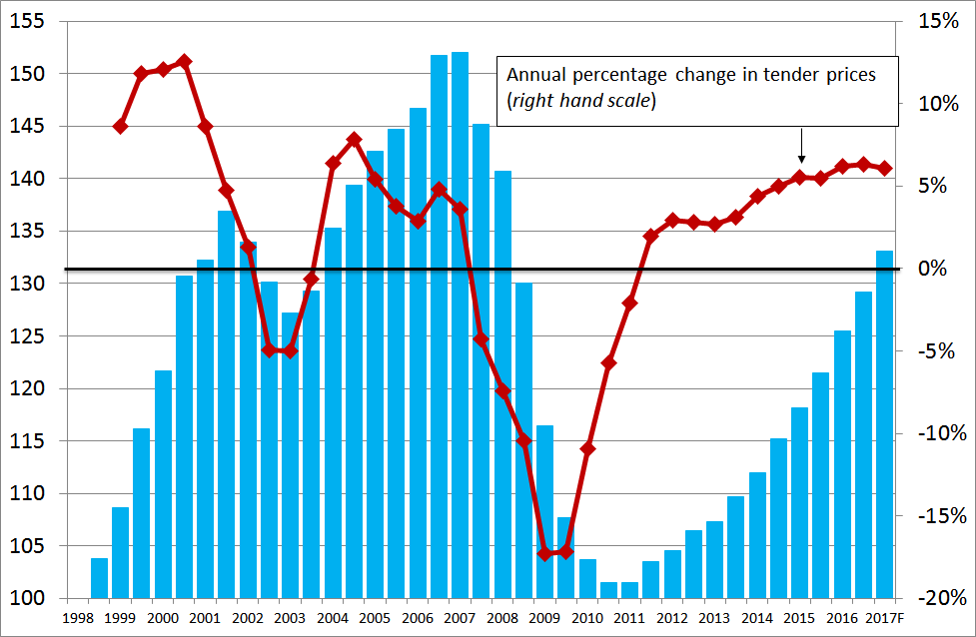
Source: SCSI.
Total construction labour costs (including employer costs) increased in 2013 (+1.8%) and in 2014 (+5%) and in 2016 (+3.4%), following a decline in 2015 (-2.5%).

Looking at other measures of construction inflation, they are less volatile compared with tender price inflation. Starting out with construction costs, the CSO official measures of inflation for building and construction costs, capital good, (materials and wages) and building materials separately have been very modest in recent years.

      - Building and Construction Inflation 2006-2016
Annual percentage changes
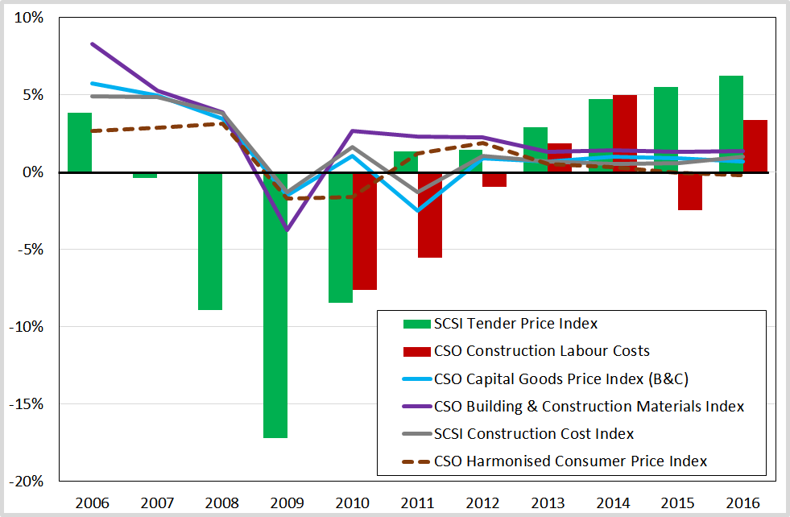
Source: CSO, SCSI.

Notwithstanding the above trends, much attention is being paid to the development viability of residential construction. This led to research by the SCSI in 2016 which reported that the actual construction costs made up less than half (45%) of the total costs of building a three-bedroom semi-detached house in the Greater Dublin Area. The other 55 per cent of the total cost of €330,000 consisted of non-construction factors, such as the cost of acquisition and development finance, design, sales and marketing, margin (including profit) and taxation elements such as levies and VAT. By incorporating all costs, the market price of the three-bedroom semi-detached house was higher than what a first-time buyer on twice average earnings could afford to borrow under the Central Bank’s macro-prudential rules.

In the last twelve months the average annual rate of house price inflation has increased from 4.6 per cent in December 2015 to 7.9 per cent in December 2016 and remained at that level in January 2017. The corresponding movement in Dublin over the year was from 3.9 per cent to 5.8 per cent, while the rate of price growth moderated to 5.3 per cent in January 2017. Similarly housing rents have risen strongly and are now ahead of where they were at the peak of the last housing boom.

While recognising that the key issue is the lack of housing supply, there is a need to understand why housing costs are rising and how the individual cost components compare with our competitors. In 2015 the National Competitiveness Council recommended that a rigorous benchmarking exercise should be undertaken “to determine whether Irish residential construction costs are out of line with those of our key competitors.” It was recommended that such an exercise “should include an assessment of the input costs, time, and procedures required to complete a number of different types of residential development.” This should also include a review of the impact on costs of the range of building and other regulations introduced since the financial crisis.
  - Recommendations
- Apprenticeship training that is structured on a regional basis, in light of the demands of the relevant area, would produce tradespeople who could remain in their communities and regions and reduce the incentive to relocate to major cities. The result should be better qualified tradespeople living across a broader geographic spread, which should secure the sustainability of the construction skills base in the long-term. This will be important in the context of the forthcoming National Planning Framework which is expected to have more balanced regional development as one of its key objectives.

- The recommendations of the CIF’s Construction Skills report regarding the enhancement of the skill’s capacity of the industry should be implemented and Government should ensure that adequate funding is in place for Solas and the Education and Training Board network to deliver the requisite numbers of highly skilled apprentices to serve the industry over the long-term. Thereafter a strong pipeline of projects will be required to ensure that those trained remain in the Irish construction sector and are not drawn towards the UK where a significant skills gap is projected in the medium-term.

- In line with a 2015 recommendation of the National Competitiveness Council, which was never acted upon, it is recommended that the Housebuilding Cost Working Group, which is currently reviewing Irish housebuilding costs, should also undertake a rigorous benchmarking exercise to determine whether Irish residential construction (building and non-building) costs are out of line with those of our key competitors.
- Key Bottlenecks and RationalE for Public Investment
  - Does Ireland have an Infrastructure Deficit?
Ireland’s infrastructure needs were comprehensively addressed by the European Commission in their 2016 Country Report for Ireland. The Commission acknowledged the resumption of strong economic recovery since 2014 and the need for Ireland to remain competitive globally. It also noted the sharp reductions during the financial crisis in transport and housing investment and to a lesser extent in the health and education sectors, which “have taken a toll on the quality and adequacy of infrastructure” and have led to “pressure points” in a number of areas, notably housing, water services and public transport.

The European Commission continue to draw attention to the investment challenges in their 2017 Country Report on Ireland in which they acknowledge that Ireland remains a very competitive destination for foreign direct investment and that: “Large multinationals are interested in basing a bigger share of their activities in the country but this can be difficult due to infrastructure and housing shortages — which also constrain the expansion of indigenous companies.”

The Commission further note that: “The barriers affecting the development of housing and infrastructure projects have become the most pressing” despite their 2016 recommendations that Ireland should “Enhance the quality of expenditure, particularly by increasing cost-effectiveness of healthcare and by prioritising government capital expenditure in R&D and in public infrastructure, in particular transport, water services and housing.”

In the Irish Fiscal Advisory Council’s June 2016 report detailing investment and depreciation, the Council also highlighted some issues of concern. The Council’s analysis expresses investment in GNP terms. The Report noted that:
- The average level of public investment was 3.7 per cent of GNP between 1995 and 2015;
- As of the 2016 Stability Programme Update (SPU), the projected levels of investment for 2016 to 2021 was to be 2.1 per cent of GNP;
- “On average, over the period 1995-2014 depreciation has accounted for 61 per cent of GFCF, with a peak of 105 per cent in 2013”.

With regard to the Capital Plan 2016-2021, the Council estimates that €4.4 billion of the €6 billion allocated to investment in roads will cover depreciation costs (i.e. 73%). Of the total infrastructure investment of €42 billion in the Capital Plan, the Report notes that this “is barely adequate to cover the estimated cost of depreciation of public capital, based on historic depreciation rates”. It notes that the public capital stock will fall as a percentage of GNP over the medium term and hence investment will not keep pace with economic growth. The CIF is very concerned about the effects of depreciation on Ireland’s capital stock and about the anticipated low replacement rate of this stock. Several indicators point to infrastructural deficits and pressure points in Ireland, as shown below.

Competitiveness
- In 2016-2017, Ireland ranked 23rd on the Global Competitiveness Index (out of 138 countries), up from 24th in the previous year. Ireland ranked 29th regarding the quality of its overall infrastructure.
- In the World Economic Forum’s Executive Opinion Survey 2016, 26 per cent of respondents cited an inadequate supply of infrastructure as the most problematic factor for doing business in Ireland. This was followed by tax rates (16%) and access to finance (16%).

Transport
- The Department of Transport, Tourism and Sport has estimated that, relative to current levels, there will be a 35 per cent increase in the number of commuting trips made by 2040: this will be the equivalence of 650,000 daily trips.
- Based on the TomTom Traffic Index for 2016, which measures congestion in cities around the world, Dublin ranks 20th amongst all cities and 5th in Europe, irrespective of size; amongst cities with a population of 800,000 or less across the world, Dublin ranks 3rd. Congestion in Dublin adds an average of 43 per cent to travel times. Moreover, the congestion levels projected for the M50 in 2023 were reached in 2015.
- In 2015, the number of passengers carried on the rail network was 1.9 billion, up 13 per cent on 2014. With demand for services increasing, this could justify expanded investment in parts of the network. In particular, the electrification of a number of railway lines would advantage many commuters and improve productivity.
- The quality of a nation’s infrastructure and the efficiency of the economy’s logistics are assumed to be positively correlated. In the World Bank Logistic Performance Index, Ireland ranked 18th in the world in 2016. This was up from a low of 25th in 2015 and down from a pre-crisis ranking of 11th in 2007. Performance in the ranking is influenced by the efficiency of logistical operations, which in turn are a function of a country’s infrastructure, amongst other factors.

Broadband
- In its Information Society Report 2016, the International Telecommunications Union ranked Ireland 21st in its ICT Development Index. Korea, Iceland, Denmark, Switzerland, and the UK occupied the top 5 spots.
- Amongst European countries, Ireland ranked 14th on the same index. The Report notes that: “the highest entry-level fixed-broadband prices in the developed world are recorded in Ireland, at USD 50 per month”. It is not clear why this is the case.

Housing
- With respect to investment in housing, a general consensus has emerged that the level of housing supply is well below an appropriate level. An estimated 81,000 new homes are needed across urban areas by 2020, according to the Housing Agency, of which around 35,000 is the minimum requirement in the Dublin City region.

- Ireland’s lack of supply is evident from the fact that the level of house completions per 1,000 of the population was less than 3 in 2016, down from 20 in 2006. The corresponding level was over 5 in Austria, Sweden, Finland, and, France and over 6 in Switzerland and Norway in 2016.

All of the above indicators point to a need to increase capital investment to resolve bottlenecks in the Irish economy.
  - Key Bottlenecks in the Economy
The need for public capital investment and the resolution of bottlenecks are influenced by demographic changes such as births, deaths, and migration, which can be used as indicators pointing to pressure on public services.

According to the CSO, there were 4,758 million individuals living in the State on Census night 2016. As of February 2017, no data is available on the breakdown of this population into age cohorts. The most recent CSO projections for population growth by age cohort were released in 2013, under a range of different scenarios. In the analysis below we have updated these estimates in line with the DKM Demographic Model, which is an appropriate tool for estimating age cohort growth in the absence of up to date CSO data.

In line with the CSO, these projections show that over the coming years the demographics of the Irish population are expected to change considerably. Table 2.1 shows the projected population, by age cohorts, in each Census year to 2031.

        - Projected Population by Age Cohort, Census Years 2016-2031 (000s)
Age Cohort | 2016 | 2021 | 2026 | 2031
0-14 Years | 1,036 | 1,072 | 1,035 | 983
15-24 Years | 559 | 592 | 671 | 745
25-39 Years | 1,044 | 951 | 892 | 919
40-59 Years | 1,259 | 1,388 | 1,470 | 1,471
60-74 Years | 606 | 685 | 761 | 844
75+ Years | 265 | 322 | 400 | 481
Total Population | 4,768 | 5,010 | 5,229 | 5,442
Source: DKM Demographic Model.

As can be observed, the population is expected to age: within four years (in 2021) there will be an additional 137,000 individuals aged 60 or over. Table 2.2 shows the projected inter-censal growth rates across age cohorts.

        - Population Growth by Age Cohort, Census Year 2016-2031 (%)
Age Cohort | 2016-2021 | 2021-2026 | 2026-2031
0-14 Years | 3 | -3 | -5
15-24 Years | 6 | 13 | 11
25-39 Years | -9 | -6 | 3
40-59 Years | 10 | 6 | 0
60-74 Years | 13 | 11 | 11
75+ Years | 21 | 24 | 20
Total Population | 5 | 4 | 4
Source: DKM Demographic Model.

Based on these projections, a number of implications emerge for specific infrastructure priorities:
- In the short term, additional investment in primary schools will be required to accommodate the 3 per cent increase in the number of children aged 14 or under up to 2021; as some of these children age, between 2021 and 2026, the number of children of secondary school going age will increase demand for spaces at this level.
- In line with these developments, the Capital Plan notes that “it is expected that the demand for school places will peak in 2018 for primary school places and 2025 for secondary school places.”
- As these teenagers leave secondary school, there will be an increased demand for third level places in the decade 2021-2031.
- Separately the Department of Education and Skills has estimated that the enrolment in primary schools will peak at around 574,000 in 2018 and at around 410,000 in the post-primary school system by 2025.
- Planning for nursing homes and retirement communities now will mitigate against the rapidly ageing population: by 2026 there will be an additional 156,000 individuals aged over 60.

In addition, population changes are likely to vary considerably across the country. Table 2.3 indicates the counties that experienced the highest rates of population growth between 2011 and 2016.

        - 10 Counties with Highest Population Growth, 2011-2016
County | (%)
Fingal | 8.1
Meath | 5.9
Kildare | 5.6
Cork City | 5.4
Dún Laoghaire-Rathdown | 5.3
Galway City | 5.3
Laois | 5.2
South Dublin | 5.1
Dublin City | 4.8
Longford | 4.6
Source: CSO Census of Population 2016.

Whilst this data does not indicate the level of capital investment that took place in each county in the period 2011-2016 (and hence we cannot identify specific county-based deficits), the data points to the locations where infrastructure is likely to have come under pressure since 2011. Given the low levels of public capital expenditure at the State level over recent years, these counties could be experiencing infrastructural deficit to a greater extent than other counties.

Projecting population growth forward allows us to identify where pressure might come on the system over the coming decades. Table 2.4 outlines the projected population of each region in each census year up to 2031, as per CSO forecasts. Last updated in 2013, the projections are underestimates as the projected population for 2016 was lower than the actual 2016 population, based on Census 2016. Nonetheless, the general thrust of the forecasts should stand. The CSO forecasts that the population of Dublin is expected to exceed 1.5 million by 2031.

        - Regional Population Projections, 2016-2031 (000s)
M2F2 Traditional Scenario
NUTS III Region | 2016 | 2021 | 2026 | 2031 | 2016-2031  AAGR %
Border | 518 | 526 | 531 | 533 | 0.2
Dublin | 1,297 | 1,373 | 1,448 | 1,519 | 1.1
Mid-East | 561 | 600 | 639 | 678 | 1.3
Midland | 293 | 302 | 307 | 309 | 0.4
Mid-West | 383 | 393 | 403 | 410 | 0.5
South-East | 514 | 531 | 542 | 550 | 0.5
South-West | 678 | 701 | 719 | 733 | 0.5
West | 443 | 451 | 455 | 456 | 0.2
State | 4,687* | 4,876 | 5,044 | 5,188 | 0.7
Source: CSO Regional Population Projections (Dec 2013). * Actual 2016 Population = 4.758 million.
AAGR = Average annual growth rate.

Given that the CSO’s projections were made during a period of economic decline, it is not unreasonable to expect higher rates of population growth over the coming years, in particular due to Dublin’s recent strong economic performance. This could be driven by returning emigrants, the immigration of non-nationals, and a higher birth rate. In that context, we consider the CSO’s estimates for regional population growth to be an underestimate. Infrastructure planning that relies solely on such projections may miss underlying ‘live’ developments, in particular with respect to net migration. We encourage recognition of this in planning for capital investment over the coming years.
  - Addressing Long-Term Infrastructure Planning
The delivery of an efficient roll out of much needed infrastructure on time and within budget should be central to infrastructure planning in the long-term. Current responsibility for planning rests with a number of stakeholders including government departments, regulators, local and regional authorities and state agencies. Seperately the PPP process can involve a lengthy pre-procurement process as well as additional stakeholders. The current approach to planning is described by the National Competitiveness Council (NCC) as one which is characterised by “fragmented planning and coordination” which “can contribute to cost overruns and delays, duplication of resources and weaken the ability to prioritise projects and locations for capital investment.”

The NCC calls for an effective, integrated and coherent approach to State led infrastructure planning and delivery which could facilitate improved efficiency and enhance the effectiveness of capital investment at minimum cost. In this regard, it recommends that the Department of Public Expenditure and Reform (DPER) should undertake a review of how other advanced economies coordinate and deliver capital investment and should identify best practice in terms of the institutional framework for capital infrastructure investment.

A long lead in process applies to development of any major infrastructural project. Long term planning is now required for projects to be delivered in 2 to 3 years’ time and indeed in longer timeframes. Long term planning of future infrastructural projects cannot be sacrificed to meet other short term revenue requirements. The strategic infrastructure planning approval process in An Bord Pleanála works well. Every effort should be made to progress the planning phases of critical infrastructure projects through An Bord Pleanála at the earliest opportunity so that the statutory planning requirements can be addressed in the short term.

The CIF has separately made numerous submissions to the Department of Housing, Planning Community and Local Government seeking legislative amendments to the planning control process to bring about greater planning certainty to private sector project promoters. These submissions called for, inter alia, statutory timeframes for planning authorities’ approval of planning compliance documentation, timeframes for taking in charge of development estates, standardisation of planning conditions, timely release of development securities and bonds and timely scheduling of pre-planning consultations. Implementation of a number of these suggested amendments will remove some of the uncertainties facing project promoters in pursuing viable investment and development opportunities.
  - Why Invest in Public Infrastructure?
Investment in infrastructure is important in a small open economy which has an expanding population and for which competitiveness is central to economic growth. Secondary effects, such as the job creation that accrues from different kinds of investment projects, are also important.

The quantum of capital investment should ultimately be determined by the infrastructure needs of the economy and by ensuring that the infrastructure put in place:
- Adds to the productive potential of the economy;
- Caters for the growth in population;
- Addresses bottlenecks or cost inefficiencies in the economy;
- Provides value for money;
- Generates an economic rate of return above the cost of funding the infrastructure; and
- Generates direct employment, which in turn leads to the creation of indirect employment in Irish firms right back through the supply chain and induced employment in the wider economy, as the wages and profits from the direct and indirect employment are spent on Irish goods and services in the wider economy.

The economic recovery in Ireland continues at the fastest rate in Europe. The annual GDP growth rate of 5.2 per cent in 2016 was followed by Malta (5%) and Romania (4.8%), which recorded the next highest growth rates in the EU 28 countries. Looking at short-term official forecasts, it is clear that the Irish economy will grow at a much more subdued rate in 2017 than occurred in 2014, 2015 and 2016. With uncertainty looming over the exit strategy of Britain from the European Union, the GDP growth rate is expected to be more subdued in 2017 at 3.3 per cent.

The medium-term macroeconomic forecasts from the Department of Finance were produced following the British decision to leave the EU and prior to the US presidential election and projected an average GDP growth out to 2021 of around 3 per cent.

However, the ESRI 2016 Medium-Term Outlook, which was published post the Trump election, projects GDP growth of approximately 3.5 per cent on an annual basis between 2016 and 2025, much of which will be driven by a continued strengthening in net exports. The ESRI also projects the unemployment rate to continue to fall to 6.4 per cent by 2025 in conjunction with growing employment to just over 2.3 million in 2025 from the current level of 2.05 million in Q4 2016.

Ireland’s population is projected to experience steady growth over the next thirty years. Depending on the assumptions for migration and fertility, the population is projected to grow by between 324,000 (weakest scenario) and 2.1 million (strongest scenario) to between 5 million and 6.7 million by 2046. On average, this is equivalent to an average population increase of 1.2 million over the next 35 years.

      - Projected Change in Population to 2046
(Annual average growth rates)
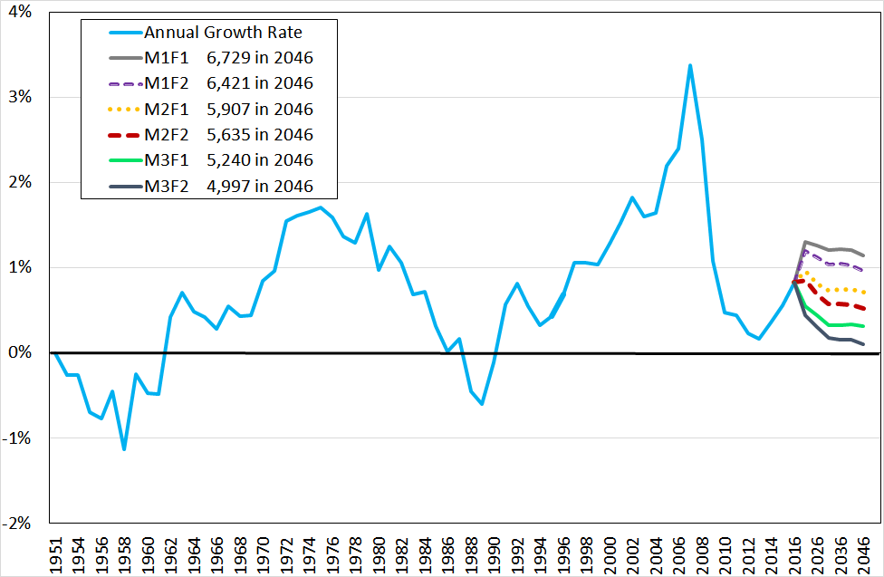
Source: CSO Population and Labour Force Projections 2016-2046, April 2013.
This growth will require a significant investment in infrastructure. The Taoiseach, Enda Kenny, has stated that: An island of 10 million people by 2050 presents a challenge for all of us. But if we are to turn this challenge into real opportunities we need to work together, in planning and investing in the infrastructure necessary for the medium to longer term.”

Where it can be shown that bottlenecks are actively constraining the economic output of the economy, and thus holding back the recovery and employment growth, investment in infrastructure to tackle those bottlenecks should be prioritised. This includes, for example, housing, transport and water, where such bottlenecks can increase living costs and thus wages, and make areas less desirable as places to live and work.

Ensuring that value for money is obtained with respect to infrastructure projects will involve two main objectives: keeping construction costs within or under budget and making sure the outcomes delivered produce the desired quality at an economic cost. This can involve a comparison between different procurement options, such as the traditional public sector procurement route model and PPP. Given existing fiscal constraints, the PPP route should be examined for major infrastructure projects which can facilitate economic development in the long-term.

Infrastructure investment has a positive effect on economic growth and jobs
In terms of the employment impact of construction projects, an analysis from the Government Economic & Evaluation Service estimated that a minimum of 12 job years are created in the construction sector for every €1 million worth of construction investment. Whilst this should not be its primary focus (infrastructure investment is not an end in itself), it is of course relevant. All else equal, an investment that entails more Irish employment should be favoured.

In a separate analysis undertaken by DKM, it was estimated that 10 direct and indirect FTE (full-time equivalent) work years are generated per €1 million of construction investment. This increases to almost 12 FTE work years when induced impacts are taken into account. The impact on the Gross Value Added (GVA) was such that the direct and indirect multiplier associated with a €1 investment in construction raises economic activity by €0.7. When induced impacts are included, the multiplier increases to €0.9. Thus a €1 million construction projects will, on average, increase economic activity by almost another €1 million euro, after all direct, indirect and induced impacts as well as imports are taken into account. These figures ignore the economic impact of the infrastructure put in place during its operational lifetime.
  - Recommendations
- The Irish Fiscal Advisory Council has expressed concern that Ireland’s quantum of capital expenditure is barely covering the depreciation costs of the capital stock. If additional finance does not become available, this increases costs in the economy in the short term (as poorer infrastructure reduces efficiency) and in the medium- and long-term (due to the need to upgrade). At a minimum, the quantum of expenditure allocated to capital projects should be sufficient to cover depreciation and tackle the backlog in a number of sectors, notably housing, transport, health and education.

- There is a clear need to invest heavily in transport infrastructure over the coming years, so as to support both population growth and competiveness. In particular, as Dublin is one of the most congested cities in Europe, measures that address this problem will lead to productivity gains for the economy. In turn, this will increase competitiveness.

- The prospect of some form of customs checks on the border between Northern Ireland and Ireland, and with that delays to travel times, will reduce the productivity of cross-border road users. Improvements to the road network around the border region would mitigate these losses to productivity whilst also increasing road quality in a broader sense.

- The ageing of the population over the coming years will increase demand for services for older people. Whilst the private sector is likely to build nursing homes and retirement communities to cater for private demand, the State should ensure that public demand is catered for too. Capital investment that addresses these coming bottlenecks will free up housing stock and prevent old-age inequalities.

- Population growth in the period 2011-2016 was greatest in Dublin, its surrounding counties, and Cork and Galway, suggesting that urbanisation increased during the recession. With publication of the National Planning Framework, it is expected that this trend will continue over the coming years, with Dublin and the Mid-East likely to grow at faster rates than other regions. Although investment should be needs-based and should focus on the regions where demand is highest, this should not be at the expense of other regions.

- The mid-term review of the Capital Plan should examine best practice in terms of the planning and institutional framework for the roll out of capital infrastructure projects.

- Public Capital Investment Trends
  - Public Capital Investment Review
The allocations for capital investment are published at the time of the Budget each year. More detail follows with publication of the Revised Estimates for Public Services each year by the Department of Public Expenditure and Reform (DPER).

Table 2.1 provides a breakdown of exchequer voted capital expenditure and total expenditure on capital (including both exchequer and non-exchequer spending) as provided for in the Public Capital Programme (PCP) over the period 2008 to 2017. Voted capital expenditure in 2017 is roughly half what it had been in 2008, whilst total expenditure on capital in 2017 is almost two-thirds what it had been in 2008.
        - Public Capital Expenditure 2008-2017
Source |  | 2008 |  | 2009 |  | 2010 |  | 2011 |  | 2012 |  | 2013 |  | 2014 |  | 2015 |  | 2016 |  | 2017
Exchequer Voted Capital (€m) | 9,011 |  | 7,333 |  | 6,385 |  | 4,515 |  | 3,809 |  | 3,387 |  | 3,597 |  | 3,730 |  | 4,240 |  | 4,541
Total PCP (€m) | 12,495 |  | 11,849 |  | 10,365 |  | 6,963 |  | 5,699 |  | 5,699 |  | 6,166 |  | 6,746 |  | 7,452 |  | 7,636
Exchequer as % of PCP | 72 |  | 62 |  | 62 |  | 65 |  | 67 |  | 59 |  | 58 |  | 55 |  | 57 |  | 59
Exchequer as % of GNP | 5.6 |  | 5.2 |  | 4.6 |  | 3.2 |  | 2.7 |  | 2.2 |  | 2.2 |  | 1.8 |  | 1.9 |  | 2.0
PCP as % of GNP | 7.8 |  | 8.4 |  | 7.5 |  | 5.0 |  | 4.0 |  | 3.8 |  | 3.8 |  | 3.3 |  | 3.4 |  | 3.3
Source: Revised Estimates for Public Services 2017. Department of Public Expenditure & Reform – Databank & CSO. PCP = Public Capital Programme.

The total Exchequer capital provision represented 1.8 per cent of GNP in 2015 and 1.9 per cent in 2016, compared with 5.6 per cent in 2008. In terms of the larger PCP, it accounted for 8.4 per cent of GNP at the peak and fell to 3.3 per cent, where it has remained since 2015.

Figure 3.1 below shows the total public capital investment on a sectoral basis as a percentage of GNP since 2008. Whilst the recession led to a contraction in the total quantum of investment made in all sectors, since the recovery the pickup in investment has been mainly in the area of social infrastructure. Since 2008, total capital investment was at its lowest in 2012 and 2013. Since 2013, the level of investment in social infrastructure has increased strongly (+89%) and has been much larger than the corresponding increase in investment in productive infrastructure (+9%).

In GNP terms, social infrastructure investment increased from 1.1 per cent of GNP in 2013 to an estimated 1.4 per cent in 2017, but is well down from almost 3 per cent of GNP at the peak. In contrast investment in productive infrastructure declined to 1.7 per cent of GNP in 2015 and is estimated to represent 1.6 per cent in 2017, compared with 4.6 per cent at the peak. The trend in productive infrastructure investment highlights the acute situation in the civil engineering sector which has consistently been performing poorly relative to other sectors in the industry.

      - Public Capital Programme Allocations by Sector 2008-2017E
Percentages of GNP
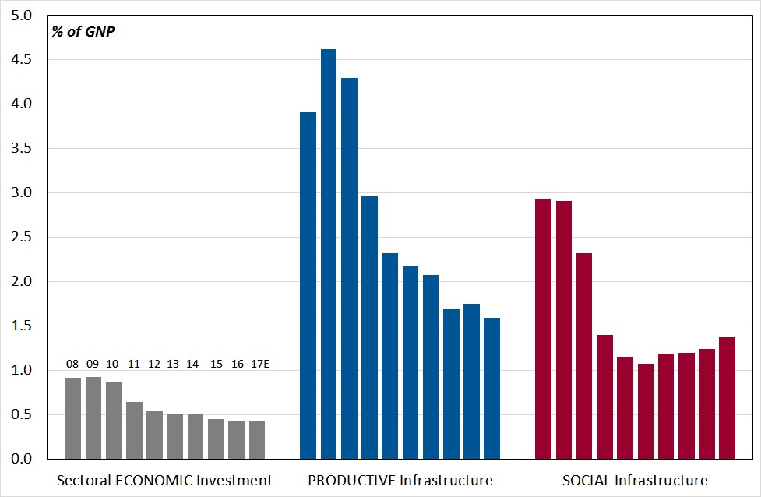
Source: Revised Estimates for Public Services 2017.

In the following section we compare the Capital Plan 2016-2021, as published in September 2015, with Budget 2017 (October 2016) and with the Revised Estimates for Public Services 2017, (December 2016). This allows us to assess the extent to which changes to planned capital spending have been made since the Capital Plan was launched.
  - Public Capital Investment Prospects
The Multi-Annual Capital investment Framework
The Capital Plan allocated €27 billion of Exchequer funding to gross voted capital expenditure over the period 2016-2021 (€4.5 billion on average per year). Of the total Exchequer funding of €27 billion, 29 per cent is allocated to transport, 13 per cent to housing, 14 per cent to education, and the remainder to other sectors.

There is an additional €14.5 billion of non-Exchequer funding allocated to capital investment from the own resources of semi-state bodies. Of this investment, 40 per cent is allocated to investment in energy, 27 per cent to water services, 5 per cent to transport, and the remainder (28%) to other areas.

Since publication of the Capital Plan in September 2015, additional funding has been allocated to capital expenditure via Budget 2017 and the Revised Estimates for Public Services 2017 (Table 3.2).
- Budget 2017 allocated an extra €3.1 billion between 2017 and 2019 and an extra €7 billion between 2017 and 2021. The additional €7 billion allocated for the period 2017 to 2021, on top of the €27 billion already allocated in the Capital Plan means the Exchequer envelope for this period is now increased to €34 billion.
- The Revised Estimates for Public Services, published in December 2016, increased the allocation for 2017-2019 marginally, by €2 million.

        - Exchequer Gross Voted Capital Expenditure (2016-2021, €m)
Date | Publication | 2016 | 2017 | 2018 | 2019 | 2020 | 2021 | Total 2016-2021
Sep-15 | Capital Plan | 3,800 | 3,971 | 4,230 | 4,600 | 5,000 | 5,400 | 27,001
Oct-16 | Budget 2017 | 4,165 | 4,535 | 5,295 | 6,070 | 6,675 | 7,285 | 34,025
 | Difference  (v Capital Plan) | +365 | +564 | +1,065 | +1,470 | +1,675 | +1,885 | +7,024
Dec-16 | Revised Estimates | 4,240 | 4,541 | 5,292 | 6,069 | No data | No data | N/A
 | Difference  (v Budget 2017) | +75 | +6 | -3 | -1 | n/a | n/a | +77
Source: Capital Plan, Budget 2017, Revised Estimates for Public Services 2017.

The total Exchequer capital provision represented 1.9 per cent of GNP in 2016 and is projected to rise marginally to 2 per cent in 2017 (Table 3.1), 2.2 per cent in 2018 and 2.4 per cent in 2019, compared with 5.6 per cent in 2008.

In regard to the Capital Plan, the National Competitiveness Council has remarked that: “The availability of world-class infrastructure in telecommunications, energy, water and transport is necessary to support sustainable growth. The Capital and Investment Plan 2016-2021 is welcome but not enough to ensure we have the infrastructure to support growth without costs rising rapidly.” The Council further expresses concern about the low levels of investment projected over the medium-term: “While recent capital expenditure commitments in Ireland are welcome – present levels of investment are insufficient to close the knowledge and economic infrastructure gap between Ireland and our key competitors which still persist. Indeed, as previously noted by the Council, current expenditure plans may be insufficient to maintain and add to the existing infrastructure stock allowing for depreciation. The relatively low levels of net investment projected over the medium term represent a significant challenge in light of demographic pressure, EU budgetary commitments and clear infrastructure deficits in housing, health, education, innovation, transport and water.”

Further evidence of Ireland’s low rate of investment is evident from Eurostat data which shows that Ireland spent the least on ‘general government fixed investment’ (voted capital investment) amongst all EU countries, as a percentage of GDP, at 1.7 per cent in 2015. The average rate was 2.7 per cent for the EU19 and 2.9 per cent for the EU28.

      - General Government Fixed Investment (% of GDP, 2015)
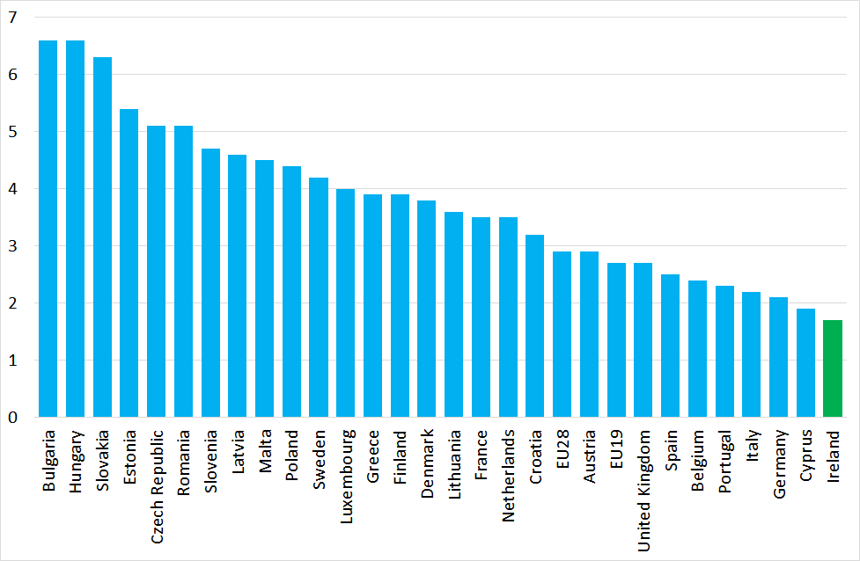
Source: Eurostat

Notwithstanding the uncertainties with regard to Ireland’s GDP as a measure of economic output, Ireland spends the lowest amount on exchequer capital investment as a percentage of GDP. One option open to the Government to guarantee capital investment year-on-year would be legislate ex ante for public investment targets, as a ratio of GDP. This would set in stone the rate of investment that the government would be obliged to meet over, for example, a 10 year period. It would also allow stakeholders to measure government progress against stated objectives. Alternatively, investment rate floors can be set so that investment does not fall below a certain level. This proposal has been made in the UK context. In both of these cases, investment targets would provide the Oireachtas with a greater level of oversight and would imply a greater level of accountability by Government.

Although the quantum of capital expenditure is influenced by resource availability and Government priorities, fiscal rules can push states to fund capital expenditure off-balance sheet. This appears to be the case in Ireland. In terms of the funding sources for total expenditure in 2017, 63 per cent is expected to come from the Exchequer, 21 per cent will be funded from the internal resources of semi-state companies and local authorities, and 16 per cent will be funded from external sources. A breakdown of this allocation is shown in Table 3.3. It is not clear to what extent capital investment in other countries is funded by non-Exchequer sources.
        - Sources of Total Expenditure in the Public Capital Programme (2017, €m)
Source | €m | %
Exchequer: Voted & Non-Voted | 4,821 | 63
Semi-States: Internal Retained  (e.g. income, own resources) | 1,609 | 21
Semi-States: Externally Funded  (e.g. borrowing, EU receipts) | 1,206 | 16
Grand Total | 7,636 | 100
Source: Revised Estimates for Public Services 2017.

The specific allocations of voted capital expenditure across a number of core infrastructure spending departments are set out below.

Education
The total allocation for Education in the Capital Plan is €3.82 billion over the period 2016-2021. Looking at the next three years, the Capital Plan allocated €599 million to the Department of Education and Skills for 2017, €623 million for 2018, and €654 million for 2019. Based on Budget 2017, there would be €690 million available to the Department in 2017, €715 million in 2018, and €746 million in 2019. The Revised Estimates increased the allocations for the respective years marginally. Altogether, an additional €185 million has been allocated to the Department since the Capital Plan was published in 2015.
        - Department of Education & Skills: Voted Capital Expenditure (€m)
 | 2017 | 2018 | 2019
Capital Plan | 599 | 623 | 654
Budget 2017 | 690 | 715 | 746
Revised Estimates | 693 | 714 | 745
Difference (v Capital Plan) | +94 | +91 | +91
Source: Capital Plan, Budget 2017, Revised Estimates for Public Services 2017

Within Education, the programme comprises a lot of relatively small projects compared to Transport for example. There are 310 major school building projects in the Capital Plan, which include 156 at primary level, 124 at post-primary level and 30 special schools. In total 62,000 additional school places will be provided, comprising 19,000 primary and 43,000 post-primary places. Subsequent to the Capital Plan, Minister Bruton announced patronage of 9 new post-primary schools to be established in 2017 and 2018, providing 8,200 additional places.

Issues of concern for the Education budget
There are three issues of concern for the education budget:
- The limited amount allocated for third-level facilities;
- The large unitary charge in the budget for 25 schools built using the PPP model; and
- Construction inflation with the average build cost for schools currently around €1,210/sqm, compared with €1,230/sqm in 2006 and €930/sqm in 2009.

In 2016, for example, of the total capital expenditure of €704 million, just €32m is allocated to higher education and €85m or 12 per cent is allocated to PPP projects.

The development of primary and post-primary education facilities is also procured via Public Private Partnership (PPP) arrangements. A total of 25 post primary and 2 primary schools have already been delivered by the NDFA in four separate school bundles over the period 2011-2016. The contract for the fifth school bundle comprising four post primary schools and one primary school was signed in July 2016. These are expected to be completed in 2018. There are currently no further school bundles in the pipeline due to the level of unitary payments already committed to in the Department Education and Skills’ budget.

There is a provision of €200m in the Capital Plan for higher education PPP projects and proposals are currently being assessed by the Higher Education Authority (HEA) both in the context of the PPP programme and the mid-term review of the Capital Plan. However the very limited investment in third level education facilities over the past decade is leading to a drop in the rankings of Irish universities which is likely to have adverse implications for our ability to attract international students and FDI.

Health
The total allocation for Health infrastructure in the Capital Plan is €3.06 billion over the period 2016-2021. Looking at the next three years, the Capital Plan allocated €454 million, €473 million, and €550 million to the Department of Health in 2017, 2018, and 2019 respectively. Neither Budget 2017 nor the Revised Estimates increased this allocation in the intervening period.
        - Department of Health: Voted Capital Expenditure (€m)
 | 2017 | 2018 | 2019
Capital Plan | 454 | 473 | 550
Budget 2017 | 454 | 473 | 550
Revised Estimates | 454 | 473 | 550
Difference (v Capital Plan) | 0 | 0 | 0
Source: Capital Plan, Budget 2017, Revised Estimates for Public Services 2017.

The key issue with the Health budget is that it is currently funding a small number of very large projects, many of which will require significant funding up to 2020. This leaves limited funding, if any, for smaller projects.

The Assistant National Director of Capital and Property in the HSE recently stated that the sector would need a total investment of €9 billion over the next ten years if healthcare policies are to be implemented and existing outdated facilities are to be replaced. In terms of construction projects, the Capital Plan is investing some €2.3 billion up to 2021. On the basis of a further estimated €2.5 billion in the following five years to 2026, this would still leave a gap of €4.2 billion to be funded.

Housing
The total allocation for the Department of the Environment, Community and Local Government in the Capital Plan is €3.96 billion over the period 2016-2021. Within this total, €3 billion is provided for social housing.

Following the 2016 General Election, Budget 2017 allocated €702 million to the restructured Department of Housing, Planning, Community and Local Government for capital expenditure in 2017. €655 million of this allocation is for housing. Altogether, since the Capital Plan, there has been an additional €240 million allocated to the Department for the period 2017 to 2019.

        - Housing, Planning, Community & Local Government: Exchequer Capital Expenditure and PCP Housing (€m)
 | 2017 | 2018 | 2019
Capital Plan | 623 | 709 | 685
Budget 2017 | 702 | 788 | 764
Revised Estimates | 705 | 788 | 764
Difference (v Capital Plan) | +82 | +79 | +79
Revised Estimates – Housing  (Exchequer only) | 655
PCP – Housing  (incl. non-Exchequer) | 1,004
Source: Capital Plan, Budget 2017, Revised Estimates 2017.

The total PCP provision for Housing, inclusive of non-exchequer funding, is expected to be €1,004 million in 2017, which is 29 per cent or €226 million above the corresponding provision for 2016.

Transport
The total allocation for the Department of Transport, Tourism and Sport (DTT&S) in the Capital Plan is €8.06 billion over the period 2016-2021 or €10.065 billion when 2022 is included. The total investment in Roads and Public Transport over the seven years is projected at around €6 billion and €3.6 billion respectively.

The Capital Plan allocated €1,015 million to DTT&S in 2017, €1,167 million in 2018, and €1,238 million in 2019. Based on Budget 2017, €1,130 million will be available to the Department in 2017, €1,281 million will be available in 2018, and the allocation will be €1,328 million in 2019. These allocations remained the same in the Revised Estimates 2017 but are in total €329 million above the corresponding provisions in the Capital Plan.
        - Department of Transport, Tourism & Sport: Voted Capital Expenditure (€m)
 | 2017 | 2018 | 2019
Capital Plan | 1,015 | 1,167 | 1,238
Budget 2017 | 1,130 | 1,281 | 1,328
Revised Estimates | 1,130 | 1,281 | 1,328
Difference (v Capital Plan) | +115 | +114 | +100
Source: Capital Plan, Budget 2017, Revised Estimates for Public Services 2017.
Including non-Exchequer investment, the total PCP provision for TT&S is €1.584 million in 2017, down 1 per cent on the corresponding provision in 2016 and roughly 40 per cent of what it had been in 2008. Within this total, the construction and improvement of roads is allocated €547.1 million, which is 7 per cent below the corresponding provision in 2016.

Of the €6 billion for road investment, steady state funding, which is the funding necessary to maintain, manage and renew the existing road network to keep it in an adequate condition, together with known capital commitments, is estimated at €4.4 billion. After the €600 million allocated to develop the existing pipeline of PPP road projects and the €100 million for smarter travel initiatives, this leaves just €860 million for new priority roads over the seven years and possibly less after adjustment for inflation. With no new PPP road projects contemplated in the Capital Plan, the scope for new projects is expected to be delayed until 2020. This implies that shovel read schemes cannot be progressed in the short term with a ramp up of schemes, most likely procured as design and build, expected in 2019.

There is a notable absence of the M20 Limerick to Cork motorway in the Capital Plan, which is a key route in the context of the Atlantic Economic corridor and would be important to provide greater connectivity between two urban centres and more generally between economic clusters in the south-west region. This project is estimated to cost in the region of €800 million, which is roughly equivalent to the total amount (€860m) allocated for new projects in the Capital Plan. Similarly, there are no alternative routes currently in the Capital Plan to address the congestion on the M50. While some initial research was done on the route proposed by Transport Infrastructure Ireland (TII), the Leinster Orbital Route, this route has been has shelved due to cost considerations and the focus on public transport.

The above issues are of immediate concern to the civil engineering sector, as they imply that there is limited scope for new capital investment in road projects until 2020.

As already noted the total investment in Public Transport over the seven years is projected at €3.6 billion, of which €2.6 billion represents steady state investment. Within the total PCP provision for TT&S in 2017 is €1.584 million, the total investment in public transport is €406.95m in 2017, which is 9.3 per cent below the corresponding provision in 2016.

Broadband
The broadband sector is largely privatised but the State has an important role to play in delivering a high quality and reliable connected society. The roll out of broadband is currently being delivered through the National Broadband Plan. The Plan aims to provide high speed broadband to 1.6 million (70%) of 2.3 million premises across the country. The remaining 700,000 (30%) of premises are to be covered by State intervention but will take 3 to 4 years to roll out.

The Department of Communications, Climate Action and Environment has recently stated that consumers in Ireland are spending €10 per person per day online. With online spending projected to reach €20 billion by 2020, the roll out of a reliable and high speed broadband across the country is critically important to support consumers, and SMEs as well as regional economic growth and job creation. Farming, education, business, health, tourism, communities and government should all benefit from better connectivity.
  - Fiscal Space and the Implications for Construction Investment
Typically, funding for infrastructure can be increased by unlocking new funding streams such as increasing user charges, capturing property value, and selling assets and recycling the proceeds for new infrastructure. The fiscal rules that were introduced during the economic crisis in Europe are aimed at ensuring that spending is sustainable over the medium- and long-term. However, they also restrict the ability of the State to invest for productive purposes. For 2018, the net fiscal space available for increased Government Expenditure in 2018 is €1.2 billion. This will be allocated on the basis of a €600 million increase in current expenditure, a €200 million allocation for capital expenditure increases, and €400 million for tax reductions.

According to the Summer Economic Statement, there will be a net fiscal space of €11.3 billion available to the Government over the period 2017 to 2021. This will be comprised of an allocation of €4.17 billion to current expenditure, €1.59 billion to capital expenditure, €2.54 billion to taxation, and €3 billion to a Rainy Day Fund from 2019. As can be observed, an additional €5.14 billion is allocated to capital expenditure outside of the fiscal space framework via an increase to the baseline Gross Voted Capital Expenditure allocation. However there is some inconsistency between this additional €5.14 billion of capital investment and the additional €6.66 billion over the same period 2017-2021 (Table 3.2), calculated by comparing the Budget 2017 figures with the Capital Plan.
        - Indicative Allocation of Available Net Fiscal Space 2017-2021
€million | 2017 | 2018 | 2019 | 2020 | 2021 | Cumulative
Net Fiscal Space | 1.0 | 1.2 | 3.0 | 3.1 | 3.0 | 11.3
Allocated to:
Expenditure | 0.67 | 0.79 | 1.38 | 1.48 | 1.44 | 5.76
Current | 0.61 | 0.61 | 0.95 | 1.02 | 0.98 | 4.17
Capital | 0.06 | 0.19 | 0.43 | 0.45 | 0.46 | 1.59
Taxation | 0.33 | 0.39 | 0.59 | 0.62 | 0.61 | 2.54
Rainy Day Fund | 0.00 | 0.00 | 1.00 | 1.00 | 1.00 | 3.00
Total Additional Capital | 0.25 | 0.75 | 1.18 | 1.38 | 1.59 | 5.14
Source: Summer Economic Statement.

Within the fiscal space rules, public capital investment may be averaged out over a four year period: this ‘smoothing’ process is implemented to encourage public investment and to avoid penalising Member States for spikes in capital expenditure.

So, for instance, if a Member State wishes to invest €1 billion in year t, this would ordinarily reduce the available Fiscal Space in year t by €1 billion. However, under the rules (see Appendix 4), this €1 billion investment is accounted for in four separate €250 million instalments across years t, t+1, t+2 and t+3. By implementing this approach, the Member State’s available fiscal space for year t will be larger (by €750 million), thus allowing greater flexibility for the Member State to pursue other expansionary fiscal policies. The €1 billion is still accounted for, but its impact on fiscal space is spread across a longer time period. Hence in Table 3.8 above, the quantum of fiscal space allocated to capital expenditure in 2017 and 2018 is not fully reflective of the actual level of capital expenditure in these years.

Whilst the smoothing of capital expenditure supports governments wishing to invest in infrastructure, the measure differs from the approach used by corporations, whereby the costs of investments are amortised over the lifetime of the investment. This ensures that costs are not frontloaded but are instead distributed over the years of use. Such an approach to national accounting and capital investment would provide more leeway for governments. However, as the anticipated lifetime of a State-backed investment is more unclear than the anticipated lifetime of a corporate investment, determining how to amortise presents challenges.

The quantum of fiscal space available to the Government is determined using the methodology set out by the European Commission for calculating fiscal space across the EU. In determining the allowable rate of growth in expenditure, the Commission assesses whether or not the economy is overheating. Based on the methodology applied, the Commission conjectures that the economy is close to its potential output and hence expenditure growth needs to be restricted.

The methodology relies on structural unemployment estimates, which point to an unemployment floor, and which are influenced by recent unemployment rates. Tom McDonnell of NERI noted during his attendance before this Committee in September 2016 that this calculation is flawed, as it relies too heavily on recent unemployment data. Because Ireland experienced high unemployment rates in the past decade, the structural unemployment rate is relatively high when compared to the pre-crisis rate. This suggests that the output gap is positive and hence implies the economy is overheating. If the methodology took into account Ireland’s full employment in the pre-crisis period, the economy might not be viewed as close to its potential output.

The Committee on Budgetary Oversight could encourage the Government to bring the flaws in the methodology for calculating Fiscal Space to the Commission’s attention. In addition, although the fiscal rules constrain investment, this should not preclude engagement between industry and Government to identify and resolve non-financial barriers that act as constraints on infrastructure development.
  - Flexibility in the Fiscal Rules
The fiscal rules make no differentiation between capital expenditure and current expenditure with regard to their impact on the budget deficit: each euro spent on capital and current expenditure is treated equally. The ‘Golden Rule’ is a fiscal principle according to which deficits are allowed if they have been driven by capital investment. Under this approach, current expenditure should match normal revenue and capital expenditure would be isolated from consideration with respect to the deficit. The Rule would therefore provide member states with greater leeway to borrow for investment. One drawback, however, could be that such a measure might incentivise new investment over maintenance and could result in a preference for fixed assets over intangibles: physical capital (schools) would be prioritised over human capital (ongoing training of teachers). This could result in a country becoming infrastructure rich but skills poor. Applied sensibly, the Rule could result in leeway for countries such as Ireland. As it stands, the principle has no basis in European rules.

Ireland exited the corrective arm of the Stability and Growth Pact (SGP) in 2016 and is now in the preventive arm of the SGP. This requires that Ireland meets its Medium-Term Objective (MTO) in 2018, which requires achievement of a balanced budget in structural terms. In Ireland’s case, the budgetary deficit can amount to no more than 0.5 per cent of GDP in 2018. Being in the preventive arm has implications for the leeway a country can request from the Commission with respect meeting its MTO.

In June 2014, in order to support increased investment levels and to encourage structural reforms, the European Council agreed that there was a need to explore how the existing rules of the Stability and Growth Pact (SGP) could be applied more flexibly without changing them. Following the European Council's guidance, the European Commission issued a communication on 'Making the best use of the flexibility within the existing rules of the SGP' in January 2015.

The outcome of this process was that the Commission emphasised the Structural Reform Clause, which allows a state to apply for a temporary deviation of up to 0.5 per cent of GDP from the state’s Medium-Term Objective (MTO), provided the state is not in the Excessive Deficit Procedure (EDP). The state’s planned reforms must be major, have a long-term impact on growth and budgetary sustainability, and must be fully implemented. If leeway is granted, the MTO must be reached within four years. The clause rewards past fiscal discipline by giving countries not in the EDP a better bargain. Recent examples provide some context:
- Italy was granted leeway to deviate from its MTO in 2016, amounting to 0.5 per cent of GDP to cover the cost of implementing structural reforms, 0.25 per cent of GDP for infrastructural investment and 0.1 per cent of GDP for costs related to the migrant crisis and anti-terrorism measures. This led the then PM Renzi to state that the deviation “means a green light for investment that otherwise would have been blocked".
- Lithuania submitted a request, as part of its Draft Budgetary Plan for 2017, for flexibility of up to 0.5 per cent of GDP for structural labour market and pension system reforms.
- Finland has applied for use of the structural reform clause and the investment clause for 2017. The Commission has said it “will take account of the uncertainty surrounding the output gap estimates when considering Finland's eligibility for the clause”.

A decision on the latter two applications will be made by the Commission in May 2017. The Finnish case is of particular relevance because if the Commission determines that uncertainty surrounding the country’s output gap allows the Clause to be invoked, a similar case could be made by the Irish Government for leeway to be granted in 2018.

Whilst the Structural Reform Clause could be invoked until Ireland reaches its MTO, leeway to invest is also available if the health of the economy worsens. The investment clause allows a state to deviate temporarily from its path toward its Medium-Term Objective in case of recession. A country is allowed to deviate from the adjustment path toward the MTO provided:
- The investment has a measurable positive effect on growth and public finances;
- The country is not under an EDP;
- The country is in recession (defined as negative growth or output below 1.5% of potential);
- The deviation is temporary (e.g. it is compensated within the time framework agreed in the convergence plan and does not lead to violation of the 3% deficit limit); or
- The investment is co-financed by EU institutions.

Under the investment clause, therefore, leeway is thus available if there is a negative output gap, the deviation does not put the state in the EDP, and the investment has a long-term impact on growth and budgetary sustainability. At present, Ireland does not fit the criteria that would allow the Government to apply for the investment clause. If, in the coming years, the State’s budgetary and economic situation deteriorates such that the country is eligible to invoke the clause, leeway could be applied to invest in projects that might bolster the economy.
  - Recommendations
- Ireland has been spending relatively little on capital expenditure when compared with other EU countries. The industry in other EU countries has called for the introduction, via legislation, of national investment targets (e.g. as a percentage of output). Such targets could, for example, ensure that capital expenditure grows in line with the economy. The Government could consider this policy approach as a means of ensuring that the economy and public investment move in unison.

- With the decline in the Exchequer proportion of the PCP over the past decade, the exact identity and nature of capital projects is difficult to discern. A centralised database of all capital projects being undertaken by the Exchequer and by semi-state bodies would provide stakeholders such as the CIF with greater certainty and clarity about ongoing and future work. In this regard a Cross Departmental Committee should be established to monitor progress on public sector construction projects on a quarterly basis and address any barriers which are impeding the delivery of projects on time.

- Whilst the Capital Plan provides for an allocation of funding to higher education PPP projects, there is general concern that the funding being allocated to the sector will not be sufficient to meet demand. Although an expansion of university places will be required to keep pace with population changes from 2021 to at least 2026, the Capital Plan does not appear to have accounted for this increase. The Government should re-evaluate this issue through the mid-term review of the Capital Plan.

- The absence of the proposed Cork-Limerick motorway (M20) and an outer Dublin Ring Road ((Leinster Orbital Route) from the Capital Plan has been put down to cost reasons. Given the strategic importance of the former and the significant pressure on the latter, we would welcome a review of why these projects are excluded from the Capital Plan.

- The Government plans to allocate €1bn from the Fiscal Space to a Rainy Day Fund on an annual basis from 2019. Whilst this measure could act as a buffer against future shocks to the economy and the public finances, the Government could consider postponing the allocation for 2019, at least. This would allow for greater levels of public capital investment in 2019 than that which is currently planned. Where there are good projects that earn a return and add to the productive potential of the economy, here should be scope to use the rainy day fund.

- The CIF understands that a number of commentators have criticised the EU Commission’s methodology with respect to calculating the fiscal space available to the Government. In gauging whether the economy is overheating (an important aspect of calculating fiscal space), the methodology places too great an emphasis on recent unemployment rates, which in Ireland’s case were particularly high. The Government could request that the Commission reassesses the merits of this approach for countries that experienced significant unemployment in the recent past.

- In 2015, the Commission clarified the flexibility that is available to Member States around the fiscal rules: namely, these are the Structural Reform Clause and the Investment Clause. At present, Ireland would be eligible to invoke the former but not the latter, and significant structural reforms could be undertaken in Ireland. The Government should seek to invoke this clause as part of its submission of its budgetary plans for 2018 to the Commission and we encourage consideration of same.

- Other Sources of Funding for Public Infrastructure
Alternative sources of funding are available to the Government to increase capital investment. These include securing financing for project via the European Investment Bank, the Irish Strategic Investment Fund, and utilising capital receipts.
  - European Investment Bank (EIB)
Lending to infrastructure projects is a cornerstone of the EIB’s lending objectives. In 2015, the EIB lent EUR 19.1 billion for infrastructure projects with another EUR 19.6 billion for Environment projects, many of which have infrastructure components. The EIB is active across the spectrum of infrastructure providing financing for viable projects in Transport, Energy, Water, Health, Education and Urban sectors. The Bank is the world’s largest lender for water investment worldwide and the largest lender for renewable energy investment globally.
        - EIB Projects: Number & Value in Ireland, 2012-2016
Year | Total Value of Loans (€m) | Number of Projects | Average Loan Value (€)
2012 | 505 | 5 | 101
2013 | 680 | 7 | 97
2014 | 932 | 8 | 116
2015 | 755 | 6 | 126
2016 | 825 | 13 | 63
2012-2016 | 3,697 | 39 | 95
Source: EIB.

A total of €3.7 billion in loans was provided to Ireland over the period 2012-2016. The average value of EIB loans made in Ireland halved between 2015 and 2016, whilst the number of projects supported more than doubled. This suggests that the EIB agreed to fund a larger number of lower value projects in 2016.

The investments cover a broad range of sectors and values. A total of €350 million was provided to upgrade outdated buildings and build state of the art new education and research facilities at primary and post-primary schools and at third level institutions. The investment also included the N25 New Ross Bypass, which was the first project in Ireland to be funded under the Project Bond Credit Enhancement initiative intended to stimulate capital market financing for large scale infrastructure projects. Further opportunities to avail of this initiative for other large projects should be examined.

Speaking in 2016, the Vice President of the EIB, Mr. Andrew McDowell said: ”Ireland is still not yet at the forefront of EU countries in deploying EIB financial instruments to support investment, particularly under the Investment Plan for Europe. Notwithstanding the evident infrastructure gaps and other pent-up investment requirements, total EIB exposure to Ireland remains, as a % of GDP, below the EU average. Our first term report would probably read “could do better”.”

With the EIB having opened an office in Dublin in 2016, the Irish public and private sectors need to deepen their engagement with the Bank to gain a greater share of the enhanced lending volumes and risk capacity available to the EIB. The EIB President has stated that they plan to invest over €1 billion on various investment projects in Ireland in 2017.
  - Irish Strategic Investment Fund (ISIF)
A joint European Commission and European Investment Bank initiative, known as the Investment Plan for Europe [the “Juncker Plan”], was introduced in 2014 to encourage investment in the real economy in order to boost job creation and economic growth; meet the long-term needs of the economy and increase competitiveness; and help strengthen Europe’s productive capacity and infrastructure.

A key driver of the Investment Plan is the European Fund for Strategic Investments (EFSI), which encourages investment in key areas, including transport, broadband, energy, innovation, renewable energy and energy efficiency as well as SME financing. By providing a total guarantee of €21 billion for business and infrastructure projects, of which €16 billion is from the EU budget and €5 billion is from the European Investment Bank, the EFSI aims to unlock additional investment of at least €315 billion over 3 years.

The Irish Strategic Investment Fund was established in late 2014. Its mandate includes:
- Investment performance should exceed average cost of Government debt;
- No withdrawals from the Fund are permitted before 2025;
- There should be no borrowing implications for the State; and
- ISIF’s investments must be commercial; if any investments are deemed non-commercial they may be deemed Exchequer investments and accounted for within the State’s budgetary framework.

There are two sides to the ISIF: a discretionary portfolio and a directed portfolio.
- The directed portfolio is comprised of public policy investments in Bank of Ireland, Allied Irish Bank, and the Strategic Banking Corporation of Ireland.
- The discretionary portfolio includes investments made by ISIF in Irish firms and investments. ISIF indicates that investment in infrastructure can improve economic competitiveness and that investment in R&D can improve economic sustainability.

As of 31 December 2016, ISIF’s total fund size was €20.7 billion. The Fund’s “Double-Bottom Line” requirement necessitates that an investment generates a commercial return and an economic impact. Legally, the return on the assets that comprise the entire Fund must be greater than the general government’s annual interest cost on its debt, averaged over 5 years. Over the past 5 years, the latter rate was 3.3 per cent, implying that ISIF can invest in projects that lead to a greater return than 3.3 per cent.

ISIF provides a proportionate breakdown of jobs, capital deployed, and turnover on a regional basis. As can be observed in Table 3.12, Dublin accounts for a majority of the capital deployed and a similar majority of the turnover generated. However, investments made in Dublin were less labour intensive than investments made in other regions, as Dublin generated 42 per cent of the total jobs, despite receiving 55 per cent of the capital deployed. The Munster region received 19 per cent of all capital deployed, accounted for 22 per cent of turnover, but accounted for 35 per cent of all jobs generated. This implies that the investments in the region were proportionately more labour intensive than the investments made in other provinces, as well as being marginally stronger at generating turnover than other regions.
        - ISIF Regional Economic Impact 2016 (%)
 | ISIF Capital Deployed | Turnover | Jobs
Connaught | 9 | 6 | 6
Dublin | 55 | 54 | 42
Leinster (ex-Dublin) | 13 | 16 | 15
Munster | 19 | 22 | 35
Ulster | 4 | 2 | 2
State | 100 | 100 | 100
Source: ISIF.

The ISIF has invested €2.7 billion in Irish firms and investments since its establishment. Venture Funds and Real Estate have received the greatest level of investment, amounting to a combined investment of over €1 billion. A breakdown of ISIF investments by area of investment is shown below.
        - ISIF & Third-Party Commitments (31 December 2016)
Investment Area | Total ISIF Commitment (€m)
Venture Funds | 504
Real Estate | 502
Water | 450
SME | 385
Infrastructure | 361
Other | 142
Food & Agriculture | 110
Direct Equity | 109
Energy | 79
Big Idea/Innovation | 12
Total | 2,654
Source: ISIF.
  - Capital Receipts
In 2016, the Government sold a stake in AIB worth €1.6 billion. It is anticipated that the State’s share in Bank of Ireland will also be sold off in the coming years and the Government would have a number of options with respect to these proceeds. The resources accruing from this sale could be used to pay down debt, increase capital expenditure, or reserve the revenue for a rainy day. The Programme for a Partnership Government limits the value of AIB that the Government can sell off to 25 per cent before 2018. On March 2nd 2017, AIB proposed that it would pay a dividend of €250 million to its shareholders.

Minister for Finance Michael Noonan indicated that this development could suggest that the conditions might now be appropriate to liquidate the State’s shareholding in the bank. In the current climate, where significant underfunding of capital investment is causing bottlenecks (see Section 2), any proceeds from the sale of State assets could be put to productive use and could support long-term economic growth.
  - Public Private Partnerships
PPP arrangements provide for long-term strategic planning of infrastructure projects. They provide an opportunity to fund major long-term infrastructure projects competitively off balance sheet while also facilitating social and economic development. In the context of the fiscal constraints which exist, it is understood that a group has recently been established within DEPR to review the future of PPPs. This group should investigate the timely pre-procurement process involved on PPP projects to improve their efficiency.
  - Investment Priorities for the Medium-Term
Given the significant infrastructure bottlenecks which are constraining economic recovery, it is difficult to identify priority infrastructure projects. How does one prioritise between social housing, primary schools, hospitals, water supply, roads, public transport and broadband, for example. This submission has outlined some of the existing bottlenecks which are actively constraining economic output and has set out why infrastructure investment is important.

The CIF Submission prepared for Budget 2017 identified major transport project priorities which would be expected generate an economic return for the State. The focus at the time was on transportation projects due to the existing capacity constraints in the road network that are inhibiting development and leading to observations, conditions and refusals for significant construction projects. By implication, the absence of these projects is hindering the economic recovery. Moreover, it was noted that a number of large scale developments would be dependent on major transportation projects.

However, it is acknowledged that the current project priorities are as provided for in the 2017 PCP. Many of these projects will have capital committed to them beyond 2017 and will thus remain a priority in the short and medium term, by virtue of the fact that they have already commenced. The mid-term review of the Capital Plan currently underway by DPER will reprioritise projects within the existing constrained capital envelope. Thus it is not intended here to provide a long list of infrastructure projects across the country which will need to compete for the limited funding which is available. One would expect that the selection of projects will be based on a robust economic analysis which will establish where the economic benefit exceeds the economic costs. More importantly, the focus should be on examining the scope available to government to source additional funding for infrastructure investment, particularly from the European Fund for Strategic Investment (EFSI), which is looking for projects and locations to invest in where public budgets are constrained.
  - Recommendations
- Ireland has been a recipient of European Investment Bank funding for a number of decades and in 2016 13 projects received total funding of €825m. This stream of funding is of huge value to the economy and Government efforts to secure EIB co-financing of major projects should continue. However, the flow of funds is uncertain and competition has increased in recent years (since Romania, Bulgaria and Croatia joined the EU). The CIF encourages the Government to leverage the presence of the new EIB office in Dublin in its efforts to find ways to fund major infrastructure projects.

- PPP arrangements provide for long-term strategic planning of infrastructure projects. They provide an opportunity to fund major long-term infrastructure projects competitively off balance sheet while also facilitating social and economic development. In the context of the fiscal constraints which exist, it is understood that a group has recently been established within DEPR to review the future of PPPs. This group should investigate the timely pre-procurement process involved on PPP projects to improve their efficiency

- Every effort should be made to explore the scope to secure as much additional funding as possible for infrastructure investment from the European Fund for Strategic Investment (EFSI). Key areas which the EFSI fund include transport, environment, health, energy and social housing. In regard to the latter the ESFI has set up a High Level Task Force to develop financing models for social infrastructure, an area in which the EFSI is keen to finance projects in the future and is already doing so in other countries.

- Appendix 1: Capital Plan Allocations for 2016-2021
Main Areas of Investment | Investment | Priority Areas/Key Projects 2016-2021
Public Sector Infrastructure  - Exchequer Funding  - State-owned investment  - PPPs | €42bn (+€4bn)  €27bn  €14.5bn  €0.5bn | Total Capital Plan is expected to support in the region of 45,000 jobs over six years, excluding the additional €7bn allocated in the 2017 Budgetary projections to 2021.  This excludes the additional €7bn in the 2017 Budget.  The total capital investment associated with the key areas/projects listed below amounts to €32.7bn over the six years 2016-2021, including an updated figure for housing from the Housing Action Plan.
Energy Transmission and Distribution Networks | €5.75bn  by ESB, Ervia, Bord Na Móna, Eirgrid | - North-South Transmission Line – a second electricity interconnector between Ireland and Northern Ireland; Smart Metering; Grid Link and Grid West – to increase the grid capacity and secure electricity supply to the south and east of Ireland and the west of Ireland, respectively;
Water and Wastewater quality and capacity | €4bn  by Irish Water | - To address the deficits in drinking water quality and capacity, wastewater quality and capacity, and repair much of the infrastructure;
Flood Relief | €430m | - Of which €348m will be directed towards major schemes;  - 6 major flood relief schemes under construction, including Ennis, Bray, Waterford, River Dodder and South Campshires Co Dublin;  - A further 30 schemes at the planning/design stage, including Cork City, Arklow Co Wicklow, Enniscorthy Co Wexford, River Poddle Co Dublin, Morrell River Co Kildare and Midleton Co Cork;
Road Improvement and Maintenance – National, Regional and Local Roads | €6bn | - €4.4bn for road maintenance and €1.6bn for new projects;  - The majority of ‘shovel ready’ National roads projects will not commence construction until 2019/20 due to funding constraints;
Education – Primary, Secondary and Third Level | €3.82bn | - To provide 19,000 primary school places by 2018 and an extra 43,000 secondary school places by 2022;  - €110 million for 3rd level facilities plus an extra €200 million via PPP’s;  - Notable projects in the 3rd level sector include, the Trinity College Business School, student accommodation at NUIG in Galway, a Library Building at the University of Limerick and the DIT Grangegorman campus development;
Healthcare Infrastructure | €3.1bn | - Projects to commence in the next three years: the National Children’s Hospital; a new 120-bed National Rehabilitation Hospital in Dún Laoghaire; the Central Mental Hospital in Portrane; and oncology centres in Dublin, Cork and Galway;  - A new emergency department (ED) to open in Limerick in 2017; two further ED’s planned in Galway Hospital and Beaumont Hospital;
Public Transport | €3.6bn | - Projects either under construction or expected to be advanced over the coming years include: Luas Cross City project; Reopening of the Phoenix Park Tunnel; the multi-phase DART expansion programme (to Balbriggan, Maynooth and Hazelhatch); upgrading of Quality Bus Corridors; new and replacement buses;  - Metro North – construction to commence in 2021;
State and Regional Airports, Seaports |  | - A new €320m runway for Dublin Airport due to start mid-2017;  - Investment in upgrading regional airports of around €38m;  - A number of seaports have expansion plans;
Third Phase of PPP’s – Transport,  Education,  Justice. | €500m | - Roads – 3 PPP projects underway: M17/M18 Gort to Tuam; M11 Gorey to Enniscorthy; N25 New Ross Bypass; New Road PPPs are not anticipated in the 2016-2021 period  - Education:  - DIT Grangegorman campus - 50% of funding from PPPs – a 73-acre education and health campus development comprising a primary school; a public library; sports and recreation facilities; student accommodation; Primary Care Centre; Community Nursing Unit;  - A fifth schools PPP bundle under construction comprising five schools.  - Courthouses and Garda Stations - €160m provision;
Social Housing and Housing Infrastructure – as per Action Plan | €5.5bn  (Action Plan figure) | - Address Homelessness;  - Accelerate Social Housing delivery;  - Build more private housing;  - Improve the Rental sector;  - Utilise existing housing stock.

Source: Building on Recovery: Infrastructure and Capital investment 2016-2021, September 2015. Department of Public Expenditure and Reform.
- Appendix 2: Current Investment Priorities for Health Sector
- The 473 bed National Children’s Hospital, which is currently under construction on the 50 acre campus shared with St. James’s Hospital in Dublin, will be a campus of approximately 160,000 square metres. It is expected that the hospital will open in 2020 and will cost around €1bn.
- The National Plan for Radiation Oncology, which involves four large oncology centres delivered over two phases. Following completion of Phase 1 in Dublin (St. James and Beaumont), Phase 2 involves two additional oncology centres which will be completed in Cork in 2018 and in Galway in 2019.
- The National Forensic Mental Health services facilities project, which due to commence construction in Q1 2017 at a cost of €170 million. When completed in two years, the facilities will comprise a 120 bed adult forensic hospital, together with a 10 bed forensic child and adolescent unit, and a 10 bed forensic mental health intellectual disability unit on the same site within the St. Ita’s Hospital campus in Portrane in North County Dublin.
- The new National Maternity Hospital, which is to be provided at St. Vincent’s University Hospital in Dublin and will cater for 10,000 births. This project is expected to go to tender end 2017/early 2018 and is expected to take around 42 months to build at an estimated cost of around €300 million.
- The development of Primary Care Centres (PCCs) continues with 99 centres already in operation and a further 20 under construction. 30 PCCs are due to open in 2017/2018. A total of 14 PCCs, comprising a total gross floor area of 40,753 square metres, are being delivered under PPP schemes over the next twelve months.
- Separately, there is also a medium-term requirement to upgrade/replace existing Community Nursing Units to meets HIQA (Health Information and Quality Authority) accommodation standards plus a need for additional capacity. The potential investment required is of the order of €800 million.

- Appendix 3: Pipeline of Transport Projects
The following National Road projects have planning but most are unlikely to start until 2019 or later:

Project | Status | Start | Finish
M7 Naas Newbridge upgrade | Combined with Sallins B/P & Osberstown Interchange | 2017 | 2020
N8/N25/N40 Dunkettle | ECI contract | 2019 | 2021
N4 Collooney/ Castlebaldwin | Advance works underway | 2019 | 2021
N22 Ballyvourney to Macroom | Advance works underway | 2020 | 2022
N5 Westport to Turlough | Advance works underway | 2021 | 2023
N59 Moycullen Bypass | Section of on-line improvement completed | 2021 | 2022
N56 Mountcharles to Inver | Timescale relates to Phase 1 | 2017 | 2019
N56 Dungloe to Glenties | Timescale relates to Phase 1 | 2018 | 2019

Other national roads projects which require planning, according to the NRA, include the
- N72 Mallow Relief Road,
- N2 Slane Bypass
- N6 Galway City Transport Project,
- N21//N69 Adare to Foynes, and the
- N28 Cork to Ringaskiddy.

The following Public Transport projects are either under construction or are expected to be advanced over the coming years:
- The Luas Cross City project which is under construction and is expected to be open end 2017.
- Green Line Capacity Enhancement project, including platform extensions.
- The first phase of a multi-phase DART expansion programme which includes the extension of the Dart line to Balbriggan in North County Dublin by 2022.
- Further upgrading of the core bus network infrastructure and development of a regional cities programme, with planning and design work to be progressed for two Bus Rapid Transit routes, Blanchardstown to UCD and Clongriffin to Tallaght routes, although these two projects are unlikely to be delivered until beyond 2021.
- A range of projects under the Smarter Travel initiative, including cycling infrastructure and greenways.

The most substantial project in the Capital Plan is the 16.5km metro rail link in Dublin, Metro North (€2.5bn), to address the transport needs of the Swords/Airport/City-Centre Corridor. But this project, if it proceeds, will not commence until 2021 and is expected not to be in operation until 2027.
- Appendix 4: Fiscal Space Calculation
An overview of how fiscal space is arrived at for 2018 is shown below.

- Ireland’s potential GDP growth rate, or Reference Rate, for 2018 is 3.4 per cent. This is the upper limit on allowable expenditure growth as set out under the EU’s Expenditure Benchmark, and equates to a €2.3bn expansion in fiscal space.
- A GDP Price Deflator is also applied to represent inflation in the Irish economy. This further increases the available fiscal space. The GDP Price Deflator for 2018 is 1.3 per cent of the 2018 Expenditure Aggregate. This equates to €900m. Altogether, there is an allowable expansion in expenditure of 4.7 per cent, or approximately €3.2bn, in 2018.
- However, as Ireland has not yet reached its Medium Term Objective (MTO) of a structural deficit of 0.5 per cent of GDP, its fiscal space for 2018 is reduced. A Convergence Margin of 2.1 percentage points is taken off the cumulative 4.7 per cent allowable expansion outlined above. This 2.1 percentage point decrease represents a €1.4bn reduction in the available Fiscal Space for the year.
- Discretionary revenue measures, such as non-indexation of tax bands, provide for an increase in available fiscal space of approximately €500m in 2018.
- The available fiscal space for 2018 would be €2.3bn but for pre-committed measures which reduce the Fiscal Space to a further degree. These measures will total €1.1bn in 2018 and include expenditure increases which capture demographic changes, the Lansdowne Road Agreement, and pre-commitments to the Public Capital Programme.
Once all of these factors have been accounted for, the net fiscal space available for increased Government Expenditure in 2018 is €1.2bn.

Competitiveness Challenge 2016, National Competitiveness Council., available at http://www.competitiveness.ie/Publications/2016/Competitiveness-Challenge-2016-NCC1.pdf
European Movement Conference: Investing in Ireland’s Infrastructure, Mr. Andrew McDowell, Vice President EIB, 30th September 2016.
This €5.16 billion compares with the additional €6.66 billion over the period 2017-2021 when the Budget 2017 figures are compared with the Capital Plan.
Oireachtas Committee on Budgetary Oversight, Transcript, 7 September 2016.
Estimates prepared by DKM Economic Consultants, based on the CSO’s Input-Output Tables and Enterprise Statistics on Construction.
This figure does not include civil engineering projects.
Arcadis Talent Scale – the Real Extent of Britain’s construction labour crisis, 2017 available at https://www.arcadis.com/en/united-kingdom/our-perspectives/2017/february/britain-must-recruit-one-worker-every-77-seconds-to-meet-construction-needs/
In the compilation of this submission, the CIF engaged the services of DKM Economic Consultants to assist with research and analysis.
Competitiveness Challenge 2016, National Competitiveness Council., available at http://www.competitiveness.ie/Publications/2016/Competitiveness-Challenge-2016-NCC1.pdf
European Movement Conference: Investing in Ireland’s Infrastructure, Mr. Andrew McDowell, Vice President EIB, 30th September 2016.
Oireachtas Committee on Budgetary Oversight, Transcript, 7 September 2016.
Irish Fiscal Advisory Council, Public Capital: Investment, Stocks and Depreciation. June 2016.
The output figures quoted for construction exclude the costs associated with the transfer of land and building, which amounted to €796 million in 2015. This figures is included under building and construction output for National Account purposes, generating a total value for construction output of €14.24 billion in 2015.
Demand for Skills in Construction to 2020, DKM Economic Consultants, September 2016. Available at http://dkm.ie/en/publications/reports
National Skills Bulletin, Expert Group on Future Skills Needs, Solas, July 2015, p45.
Arcadis Talent Scale – the Real Extent of Britain’s construction labour crisis, 2017 available at https://www.arcadis.com/en/united-kingdom/our-perspectives/2017/february/britain-must-recruit-one-worker-every-77-seconds-to-meet-construction-needs/
Op cit.,p49-50.
The Real Cost of New House Delivery, 2016. Society of Chartered Surveyors, 2016.
Ireland’s Competitiveness Challenge 2015, National Competitiveness Council, available at http://www.competitiveness.ie/Publications/2015/Competitiveness-Challenge-2015.pdf
Commission Staff Working Document, European Commission, Country Report Ireland 2016, p.61-62.
Commission Staff Working Document, European Commission, Country Report Ireland 2017, p.47.
Ibid. p58.
Gross Fixed Capital Formation, i.e. capital investment in building and construction and machinery and equipment.
Public Capital: Investment, Stocks and Depreciation, Irish Fiscal Advisory Council Analytical Note No. 9; June 2016, 15.
Op cit., p.16
The Global Competitiveness Report 2016–2017, World Economic Forum, p.208
Op cit., p.208
Investing In Our Transport Future - Strategic Investment Framework For Land Transport, Department of Transport, Tourism and Sport (2015), p.12
http://www.tomtom.com/en_gb/trafficindex/city/dublin
Investing in Mobility, The Importance of Transport Infrastructure, Presentation by Peter Walsh, Director Capital Programmes, TII, 27th September 2016.
Key Transport Statistics: 2015 Data, International Transport Forum (2016), http://www.itf-oecd.org/sites/default/files/docs/key-transport-statistics_2016_0.pdf
Measuring the Information Society Report 2016, International Telecommunications Union (2016)
National Statement of Housing Supply and Demand 2016 and Outlook for 2017-18, Housing Agency (2017), https://www.housingagency.ie/our-publications/latest-publications.aspx
Euroconstruct, November 2016.
http://www.cso.ie/en/releasesandpublications/ep/p-cpr/censusofpopulation2016-preliminaryresults/intro/
http://www.cso.ie/en/newsandevents/pressreleases/2013pressreleases/pressreleasepopulationandlabourforceprojections2016-2046/
Building on Recovery: Infrastructure and Capital Investment 2016-2021,DPER, September 2015, P19
http://www.cso.ie/en/releasesandpublications/er/rpp/regionalpopulationprojections2016-2031/
I.e. As of December 2013 the CSO was forecasting a national population in 2016 of 4,687 million, whereas the actual outturn as of the April 2016 Census was 4,758.
Competitiveness Challenge 2016, National Competitiveness Council., available at http://www.competitiveness.ie/Publications/2016/Competitiveness-Challenge-2016-NCC1.pdf
http://ec.europa.eu/eurostat/tgm/table.do?tab=table&init=1&language=en&pcode=tec00115&plugin=1
The consensus forecast is based on taking a weighted average of forecasts from the Central Bank, the Department of Finance, the ESRI, the IMF and the OECD.
Department of Finance, Budget 2017, Economic and Fiscal Outlook 2017. See http://www.budget.gov.ie/Budgets/2017/Documents/Economic%20and%20Fiscal%20Outlook%202017.pdf
http://www.esri.ie/pubs/EO1.pdf December 2016.
The scenarios are those prepared by the CSO and reflect different combinations of assumption about the level of net inward migration and fertility rates. See Population and Labour Force Projections 2016-2046, CSO at http://www.cso.ie/en/media/csoie/releasespublications/documents/population/2013/poplabfor2016_2046.pdf
Public Capital Programme 2016 to 2021: Labour Intensity of Public Investment, Irish Government Economic & Evaluation Service (December 2015), p.4
http://www.per.gov.ie/en/rev/
Sectoral Economic Investment: Agriculture and Food, Industry, Tourism, Fisheries, Forestry; Productive Infrastructure: Energy, Transport, Environmental Services, Communication; Social Infrastructure: Housing, Education & Skills, Health & Children, Government Construction
Appendix 1 contains a summary of the main capital investment priorities in the Capital Plan for the period 2016-2021.
Op cit., Capital Plan, p.9
Op cit., p.10
Note: the Programme for a Partnership Government proposed an allocation of a minimum €6.75 billion to capital expenditure by 2021, relative to 2016; following Budget 2017, the actual additional allocation was €7bn.
http://ec.europa.eu/eurostat/tgm/table.do?tab=table&init=1&language=en&pcode=teina210&plugin=1
General government gross fixed capital formation (ESA 2010 code P.51g) consists of resident producers' acquisitions, less disposals of fixed assets during a given period plus certain additions to the value of non-produced assets realised by the productive activity of government producer or units. Fixed assets are produced assets used in production for more than one year (Eurostat website).
General Government Fixed Investment: Annual Data, Eurostat (2016), http://ec.europa.eu/eurostat/web/products-datasets/-/teina210
Op cit., Civil Engineering Contractors Association, p.5
http://www.education.ie/en/Press-Events/Press-Releases/2016-Press-Releases/PR16-11-03.html
Presentation from the Department of Education and Skills at the Government Construction Projects and Capital Spend Conference, February 2017.
The current investment priorities for Health are provided in Appendix 2.
Presentation by the Assistant National Director of Capital and Property in the HSE at the Government Construction Projects and Capital Spend Conference, February 2017.
Refers to the Exchequer allocation for the Department of the Environment, Community & Local Government.
Revised Estimates 2017, Appendix 9.
Appendix 3 lists the pipeline of national road projects, according to the DTT&S.
Appendix 3 lists the pipeline of public transport projects, according to the DTT&S.
Revised Estimates for Public Services 2017, Appendix 9.
Summer Economic Statement, Department of Finance (June 2016), p.15. See Appendix 4 in this submission for the factors that influence the calculation of the Fiscal Space.
Of this €5.14 billion, €2.2 billion has been allocated to housing with the balance of €2.65 billion to be allocated in the mid-term review of the Capital Plan.
Refers to expenditure allocated as part of the Gross Voted Capital baseline; identified in the Mid-Year Expenditure Report 2016, p.i.
Budget 2017, Department of Finance (October 2016), http://www.budget.gov.ie/Budgets/2017/Documents/SES/Fiscal%20space%20and%20the%20Summer%20Economic%20Statement.pdf
He argued: “the structural deficit is probably the hardest thing for macroeconomists to calculate. Essentially, to even begin to calculate it, one has to come to a judgment on the extent to which the economy is overheating. One also has to calculate what the output gap is and whether it is positive or negative. The Commission's methodology is pro-cyclical. The reason for that is because it overly emphasises recent unemployment rates.” (Tom McDonnell, attendance before Oireachtas CBO, September 2016)
Making The Best Use Of The Flexibility Within The Existing Rules Of The Stability And Growth Pact, Communication from the Commission to the European Parliament, the Council, the European Central Bank, the Economic and Social Committee, the Committee of the Regions and the European Investment Bank ( December 2015), http://eur-lex.europa.eu/legal-content/en/TXT/?uri=CELEX:52015DC0012
http://www.thelocal.it/20160518/renzi-claims-victory-as-eu-gives-italy-more-budget-rules
http://europa.eu/rapid/press-release_IP-16-3664_en.htm (November 2016)
European Movement Conference: Investing in Ireland’s Infrastructure, Mr. Andrew McDowell, Vice President EIB, 30th September 2016.
https://www.rte.ie/news/business/2016/1209/837631-european-investment-bank-dublin/
Under the NTMA (Amendment) Act, 2014
All made at the discretion of the Minister for Finance.
Op cit., p.7
Op cit., Revised Estimates, p.7; http://budget.gov.ie/Budgets/2017/Documents/White_Paper_2017_final.pdf
http://www.rte.ie/news/business/2017/0302/856568-aib-annual-results/
Presentation from the Department of Transport, Tourism and Sport at the Government Construction Projects and Capital Spend Conference, February 2017.
Information Note on Fiscal Space 2017 – 2021, Department of Finance (February 2016), http://www.finance.gov.ie/sites/default/files/Information%20Note%20on%20Fiscal%20Space%202017%20fin.pdf

