Title: | 2020/07 - Pick-Up Catches Fire
What Happened / Impact?
While driving along a dual carriageway in the West, the driver felt heat emanating from the driver’s footwell. Quickly, the cab of the vehicle filled with black smoke. The driver successfully pulled the vehicle over to the hard shoulder and alighted the vehicle shortly before it went up in flames. No serious injuries were sustained but driver was suffered from shock following the incident. Contractor recently received a Safety Alert from a Client in the UK depicting an identical incident with the same root cause.
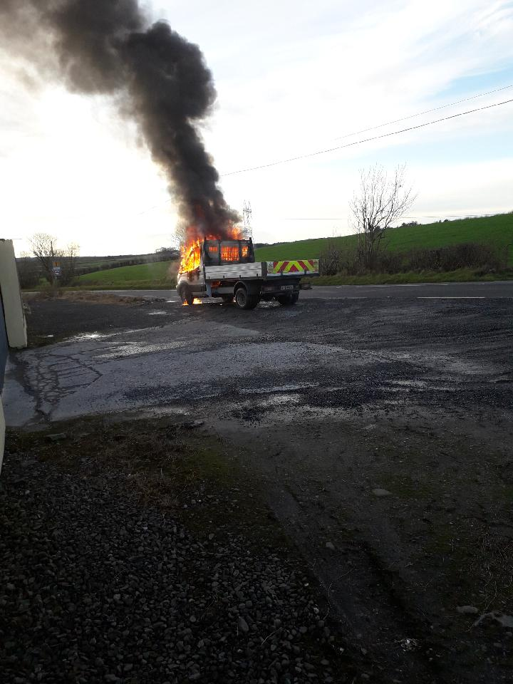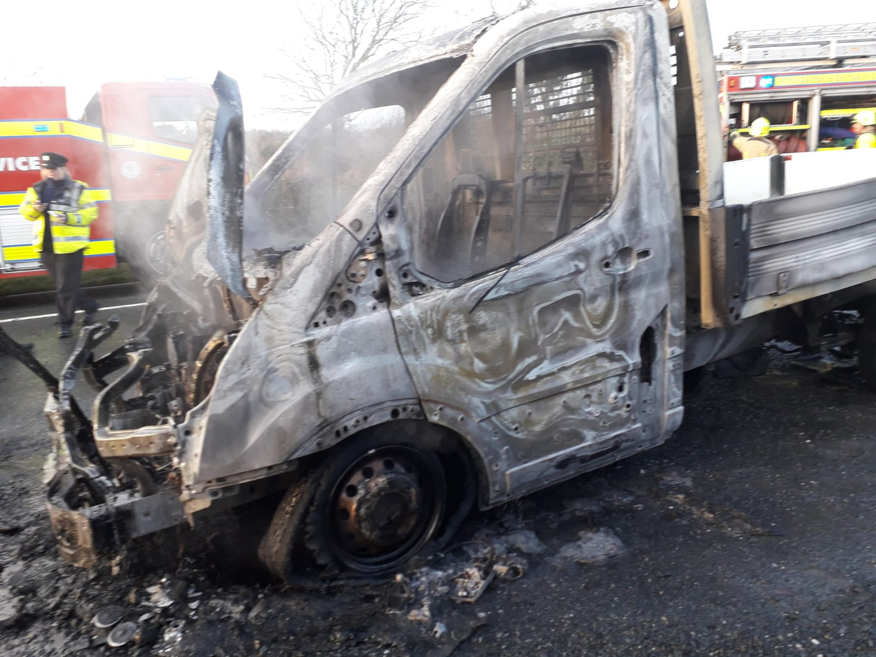
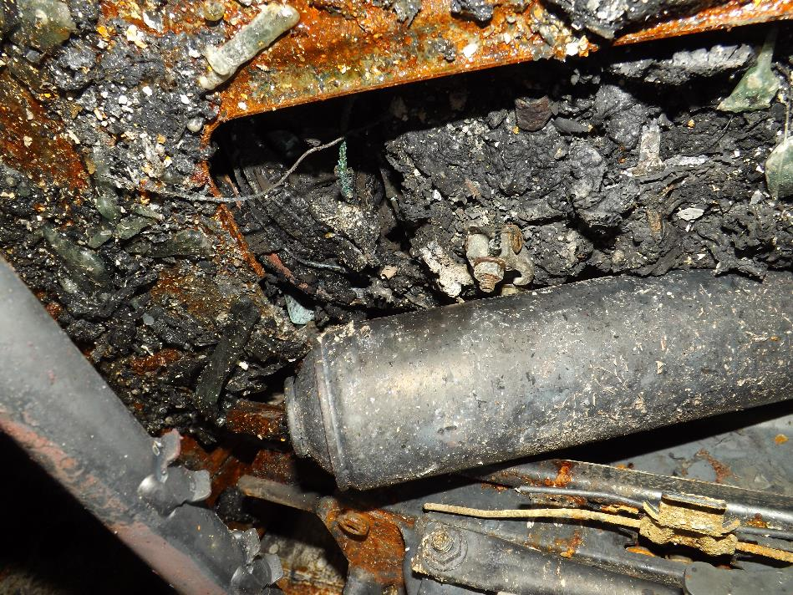
Why it Happened?
- The battery in pick-up style vehicles is located under the driver’s seat. There is a plastic cover that should be placed on top of the battery. On both occasions mentioned above, the plastic cover was missing. Loose item/material (in one case a can of spray paint) had rolled under the seat connecting the two poles on the battery resulting in combustion.
Immediate Learnings / Recommendations
- Whether owned or hired, all vehicles with the battery located under the driver’s seat should be checked regularly, and in particular, after a service to ensure the plastic cover is in place.
- Weekly plant check-sheets should include this item in their routine inspections.
For Further Information: |  | https://www.youtube.com/watch?v=xglmBiyTifQ

