SOP Title | Safe Use of Mag Drill
SOP Compiled By: | Position: |  | Signed:
 | Position: |  | Signed:
SOP Approved By: | Position: |  | Signed:
Date Compiled: |  |  | Review By:
Purpose of SOP: | To put in place a Correct safe procedure for the operation and maintenance of Mag Drill.
Scope: | Set-up and operation of Mag Drill to ensure the safety and quality is maintained to a high standard.
Responsibilities:
Supervisor:
- Ensure manufacturer’s instructions are available. Review with operator, whilst clearly communicating safety requirements.
- Ensure safety guard is supplied and working.
- Confirm competence of Operators.
- Communicate manufacturer’s instructions to operators.
- Strictly monitor apprentice / trainee / new operators for first four weeks.
- Ensure this SOP is displayed at Mag Drill location / available on site.
- Ensure equipment is in good order, guards are fitted, and leads/plugs/cables are in good working order prior to use. Check that PAT is in date.

Operators:
- Undergo training in the use of the machine prior to operating.
- Ensure plant is in safe working order with required guards in place and engraved with unique ID number and that PAT is in date.
- Operate Mag Drill safely as per manufacturer’s instructions.
- Before operation, remove jewellery, tie-up long hair, remove loose clothing, and secure high vis vest using Velcro straps.

Procedure for Safe Use of Mag Drill:
- Check set-up position is safe and not causing obstruction to access/egress.
- Ensure that access to operating zone is restricted, considering use of hard barriers and signage.
- Co-ordinate with others in work area regarding noise and associated hazards.
- Prior to start-up, check that the machine switch is set to “off” to avoid accidental start-up.
- Remember that ear protection must be worn where noise levels exceed 85dbA.
- Ensure the mag drill is secured (i.e. fix it to the surface using a strap) appropriate to the material to be drilled, when operating at a height.
- When used at a height above ground, barrier-off the area beneath.
- Ensure 110v plug is marked: DO NOT REMOVE.
- Ensure drill is square and true to work area.
- Allow the machine to drill the surface do not apply excessive force. This will burn the metal and damage the bit.
- Do not let swarf build up. Stop machine and remove using swarf stick and place in waste bin.
- Isolate the machine when changing parts in machine.
- There is a high risk of personal entanglement resulting in serious personal injury due moving parts in machine. Always keep moving parts away from the body. Always keep hands away from rotating bit and swarf.
- Do not lean into or reach across the machine at any time when in use.
- Loose clothing must be tied up, long hair put under hard hat and all hanging jewellery removed including scarves, hoodies with draw strings and ensure hi-vis vests are correct size and fully closed using Velcro straps.
- Care must be taken to avoid gloves becoming entangled in moving parts.
- Allow the machine bit to cut the metal; do not apply force.
- Use a clean approved cutting oil or paste.
- Ensure bits are clean and sharp and free from swarf and remove swarf regularly to hazard waste bin.
- Do not drill dissimilar metals (e.g. carbon and stainless steel) with the same bits.
- Use dedicated cloths for each metal type and grade.
- Clean cutting oil or paste from surface of metal.
- Discard any damaged machine parts or poorly maintained bits.
- Check for remaining swarf using a magnet.

Quality Procedures:
- Do not drill dissimilar metals (e.g. carbon and stainless steel) with the same bits.
- Use a clean approved cutting oil or paste.
- Allow the machine bit to drill metal, do not apply excessive force. This will burn the cut edge and damage the bit.
- Ensure no swarf falls on services below.
- Clean cutting oil or paste from metal.
- Brush clean using correct wire brush (Steel for Steel and Stainless for Stainless).
- Prime or seal the inside of the exposed metal.
- Use dedicated cloths for each metal type and grade.
- Clean-up and properly dispose of swarf. Carbon particles will corrode stainless steel and copper when in contact with each other. Swarf from stainless cut becomes carbonised and can corrode the metal if not cleaned off.
- Check for remaining swarf using a magnet.

Parts of a Mag Drill:
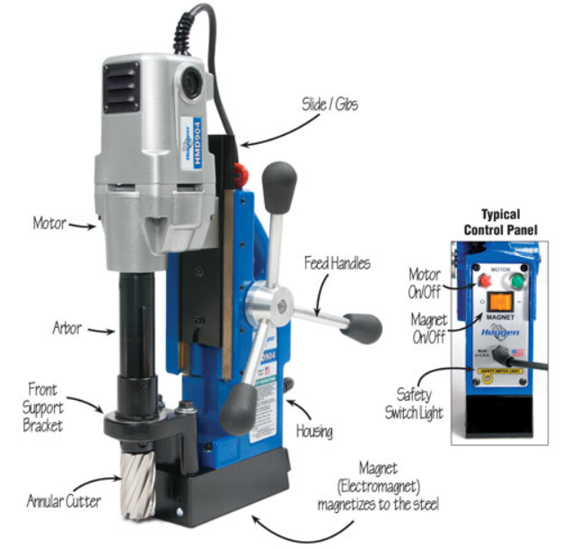
Mag Drill SOP Signoff by Supervisor and Operator
Instructor’s Name |  | Signature | Date
Operator’s Name(s) |  | Signature(s) | Date

