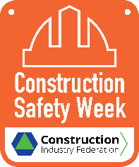
TOOLBOX TALK - ‘Mental Health and Wellbeing’

Contributors: Robert O’Dowd & Niamh Gilmore, Mercury Engineering
“At Mercury Engineering, we believe that the Mental Health & Wellbeing of our staff and supply chain is crucial to our core value of “Work Safe Home Safe”, which is at the heart of our business.
In the construction industry, it is imperative to focus our attention on the mental health & wellbeing of our people to ensure their safety and to enhance their quality of living.”
(Robert O’Dowd, Group EHS Manager, Mercury Engineering & Niamh Gilmore, Group Wellness Co-ordinator, Mercury Engineering)

Mental Health & Wellbeing – Why is it so Important?
The impact of the pandemic has been difficult for many people. The loss of income, the impact of social distancing and the fear caused by Covid-19 have all had a negative impact on our wellbeing. Some of the Main Focus Areas for Workplace Wellbeing include:
- Social Wellbeing
- Physical Wellbeing
- Mental Wellbeing.
Social Wellbeing
Social Wellbeing refers to our ability to make and maintain meaningful positive relationships and regular contact with family, friends, work colleagues & neighbours. During Covid -19 restrictions maintaining all our social relationships has been difficult.
Assessing Your Social Wellbeing! Ask yourself:
- Do I schedule time with family & friends?
- Do I enjoy spending time with others?
- Are my relationships rewarding?
- Are my relationships positive?
A “No” answer to any of these questions may indicate that you need to work on an area of your social wellbeing.
Physical Wellbeing
The benefits of physical wellbeing are well known; with regular exercise / healthy eating, you can:
- Reduce your risk of a heart attack
- Manage your weight
- Maintain lower cholesterol level
- Lower the risk of type 2 diabetes and some cancers
- Have lower blood pressure
- Have stronger bones, muscles and joints and lower risk of developing osteoporosis
- Feel better – with more energy, a better mood, feel more relaxed and sleep better.
Mental Wellbeing
“Your mental wellbeing is about your thoughts and feelings and how you cope with the ups and downs of everyday life.”
Mental wellbeing is not the same thing as mental health, although the two can influence each other. Long periods of low mental wellbeing can lead to the development of mental health conditions such as anxiety or depression. If you are living with a mental health condition, you may experience low mental wellbeing more often, but there will also be long periods where you’re able to maintain good mental wellbeing.

It is important to understand that good mental wellbeing is not the absence of negative thoughts and feelings, because difficult and challenging situations are a fact of life. Instead, it’s about being able to understand and manage the negative feelings so that you’re able to:
- Feel confident
- Build and maintain positive relationships
- Have a sense of purpose
- Live and work productively
- Cope with the normal stresses of day-to-day life
- Manage when things change.
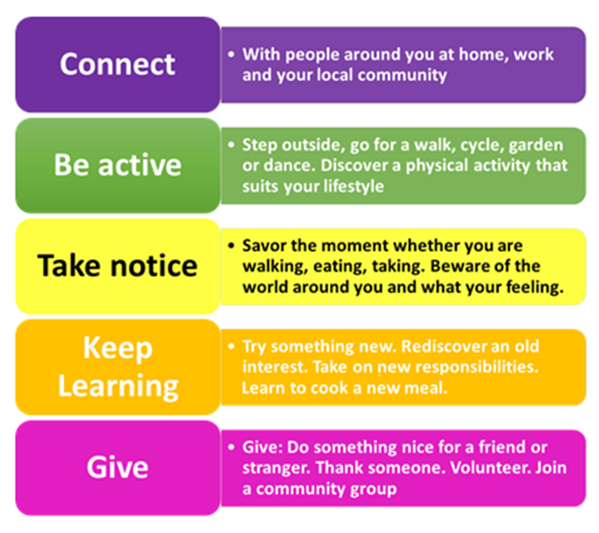
Mental Health Ireland have the ‘Five Ways to Wellbeing’ – which are simple actions to practice each day to maintain or improve our mental health & wellbeing. These are:

