‘Safe Use of Mobile Equipment’
Watch Out – There are Machines About!
According to the Health and Safety Authority, the greatest risk to pedestrians is from vehicles and mobile plant. It is highlighted that there are substantial blind spots on dozers, wheeled loading shovels and excavators, with workers at risk of being run over if they are in the operator’s blind spot.
The use of any piece of machinery should be subject to risk assessment. On construction sites, where transport vehicles, earth-moving or materials-handling machinery are used, the project supervisor for the construction stage (PSCS) must ensure that (a) safe and suitable access ways are provided, and (b) traffic and pedestrian routes are so organised and controlled to ensure their safe operation.
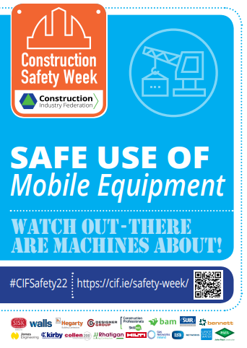
Panel Contributions
The CIF has pre-recorded a 20-min. panel discussion with industry experts, specific to the theme of ‘Safe Use of Mobile Equipment’ for CIF Construction Safety Week 2022. Watch it here: https://cif.ie/safety-week/safe-use-of-mobile-equipment/

Tim Dowling, Health and Safety Authority
- Where possible, provide separate traffic routes for plant and pedestrians. Avoid reversing. Plan works well in advance and develop a site-specific construction traffic management plan.
Niall Lohan, Ward and Burke Construction Ltd.
- Construction workers must take extra care when there are interactions with pedestrians and vulnerable road users. The public is not aware of the hazards associated with mobile plant and construction work owing to their lack of training/competency.
- Be aware that all mobile equipment has an exclusion zone.
- Less experienced operators should shadow more experienced counterparts.
- The Utilities Traineeship hosted at Mount Lucas National Construction Training Centre allows for persons to gain onsite experience in safe surroundings.
John Corcoran, PJ Hegarty & Sons Ltd. and JPC
- It is essential that the knowledge of experienced plant operators is captured and passed onto less experienced persons via mentoring.
- Always, be aware of blind spots when operating, or working in the vicinity of mobile plant.
Mossie Flynn, John Sisk & Son Ltd.
- Be mindful that mobile plant training is very general and is not specific to manufacturers.
- Take care when selecting mobile equipment, that it is the right equipment for the task and for the surrounding environment.
- Ensure that proper PPE is selected, ensuring high visibility of site workers.

