‘Safety by Example’
Lead with Influence!
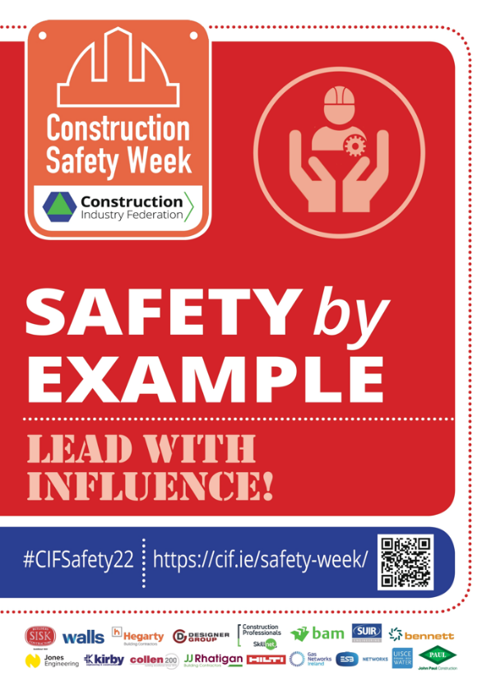
Leadership is an essential part of a health and safety management system because attitudes to safety and health are determined by top management.
Often, the best leadership approaches are those that affect others’ attitudes, beliefs and behaviours, without need for formal authoritative means.
This is at the core of health and safety management, whereby every worker, irrespective of their role, is empowered (and possesses a duty of care), to protect their own safety, health and wellbeing, and of their work colleagues.

Panel Contributions
Paul Daly, Coffey Group
- Leaders don’t have to be at the top of an organisation; everyone can be a leader in terms of safety.
Jessica Rigley, BAM
- We are all leaders. Individuals need to be accountable for ourselves.
- We must know the song, in order to sing it.
Tom Wall, John Sisk & Son Ltd.
- Draw on expertise. Protocols are in place for our safety.
- Look at current and future ways of doing things, and technology that assists, such as BIM.
Dermot Carey, CIF
- We empower people to do what they need to do.
- People follow others in front of them, hence behaviours are replicated.
Further Reading
- David Marquet on leadership: “Embedding the capacity for greatness in the people and practices of an organisation”. Source: What is leadership? - With David Marquet - YouTube
- Amy Edmondson defines psychological safety as “a belief that I will not be punished or humiliated for speaking up with ideas, questions, concerns, or mistakes”. Source: https://amycedmondson.com/psychological-safety/
- Learning from failure and human error (first and second stories) - https://www.youtube.com/watch?v=bQPCQqHkiVc
- The five principles of Human and Organisational Performance (HOP): 1. People Make Mistakes 2. Blame Fixes Nothing 3. Context Drives Behaviour 4. Learning is Vital 5. How Leaders React Matters: https://www.hophub.org/resources
- Learning from the past and ‘corporate memory loss’ - Sean Brady podcast on the Malahide viaduct near miss: Corporate Memory Loss: The Malahide Collapse

